**Study material for Semester- 5CSE**

**Module I: Group Dynamics & Team Building**

A collection of individuals who have regular contact and frequent interaction, mutual influence, common feeling of camaraderie, and who work together to achieve a common set of goals.

### A group is characterized by collection of two or more people connected with common interest and shared values and behavior expecting to fulfill them with interaction and interdependence. Group activities influence the group members and organizational activities at large extent. Organizational policies and programs are largely affecting with group influence in today's organizations. Groups can be formal and informal.  Characteristics of Group:

(1) A group consists of more than one person.

(2) They meet together to satisfy some common motive or common purpose say to collect money for flood affected persons, or national defence fund. The common motive may be biogenic or sociogenic.

(3) The group may disintegrate when the common motive is satisfied. This refers to a temporary group like a party or groups formed to collect money for relief fund or to celebrate Ganesh Puja.

But a group can also have permanent motive or purpose like family, religious groups and clubs which are formed to fulfil some permanent purposes. These are stable groups and continue for a long period. Usually sociogenic needs have got an upper hand in group situation.

## Characteristics of Group in Organizational Behavior (OB)

### 1. Collection of two or more people

A group is formed with collection of two or more individual having common objectives or goals. Groups come in existence with interaction and interdependence. Groups exist till the motivation of group members being member or till the fulfillment of group goals.

### 2. Shared interest

Individual having common interests and objectives join group. Shared interest help to accept the group norms and values. For instance, employees join union with common interest of security and prosperity.

### 3. Interaction and interdependence

To satisfy the shared objectives, group members interact to each other with formal network of communication. They share ideas and experience for better output. Each member becomes dependent to other members for activities and quality of result. In general, groups are formed with complementary skills i.e. interdependent in skills.

### 4. Group identity

Each member in the group gets collective i.e. group identity. Members get distinct identity as being member of group. Values and importance of members of group and non-members are different. Society or management gives different recognition to the group members.

### 5. Defined structure

In general, group has defined structure. Roles, responsibility and authority are clearly defined. Groups set the clearly defined channel of communication.

### 6. Group values and norms

For effective functioning of group, each group establishes common values and norms. Such values and norms are accepted by each member for fulfillment of group objectives.

## Reasons for Joining Groups in Organizational Behavior (OB)

Groups are formed by organization at different levels and from individual employees at their will. In this way, groups can be formal and informal. Almost all employees joining organization wish to join group whether it can be formal or informal. An employee may be member of many groups within and outside the organization.

### A. Employee's view point

Employees join group to satisfy of individual needs. They wish their job security, identify, power and goal achievement. Following reasons are common to join group by employees:

#### 1. Security

Individual wish to join employees union or other groups in order to insure their job security. They think the collective voice gets strong bargaining capacity on their interest. To pressurize the management for job security, financial security and physical security, employee wish to join group.

#### 2. Identification

Group provides collective identity. Collective identity and status increases the level of satisfaction. To get benefits of status and identity, individual wish to join group.

#### 3. Power

By joining group, employee may get authority. Organization fixes responsibility-authority relationship in formal groups. Authority is assigned to the member of groups.

#### 4. Goal achievement

Individual believe that their goals can be achieved being member of group. Normally, goal accomplishment becomes possible only with the joint effort. To get joint effort i.e. synergy effect of effort, employees want to join group.

### B. Organization's point of view

Organization for various purposes, form formal groups. Decision making, planning, execution of plans, etc. become more effective with joint effort.

#### 1. Communication

As formal groups have formal structure, flow of formal communication becomes easier with formal chain of command which becomes impossible by individual communication.

#### 2. Plan execution

It becomes easier to execute the plans made by management to accomplish the organizational goals. If formal and informal groups are convinced to the organizational plans, they convince the members and even non-members of the organization. It will be easier to execute plans with motivated employees.

#### 3. Decision making

Effective decisions can be made with group of people. Identification of alternatives, determination and analysis of premises, future estimation, etc. are required for effective decisions become effective with many heads. So, effective decisions can be made with joint effort of group.

#### 4. Socialization

Groups help to socialize new employees regarding organizational culture, working procedures, rules and regulations. This helps to reduce the burden of managers.

## Stages of Group Formulation in Organizational Behavior (OB)

Group formulation takes a series of stages. Social scientists have concluded that there is no fixed rule for group formulation. Basically, following five stages should occur for effective group formation by Tuckman (1965)

### 1. Forming Stage

People willing to join group contain number of queries, confusion and uncertainties regarding group goals, leadership, norms and values. In this stage, these people introduce each other and get the description regarding group and its norms. People may not understand the group norms, purpose, structure, leadership, and acceptable behaviors clearly. This means people show their willingness to join the group but there is no certainty of joining the group.

### 2. Storming Stage

In this stage, high degree of conflict and confrontation takes place. It is characterized by many changes in membership expectations, interpersonal styles, problems of groups goal and individual goals. Conflicts may arise in leadership, authority and control. These things can be settled with negotiation. This means, leadership, groups goals, group norms and values are fixed in this stage. Members accept these things with the end of this stage.

### 3. Norming Stage

In this stage, members start cooperation in group efforts. They develop harmonious relationship among group members. Feeling of we instead of I is developed. They show group cohesiveness and group identity. This stage will be completed after accepting a common set of expectation and way of doing things.

### 4. Performing Stage

In this stage, each member of the group show matured behavior. Group is thus, characterized as matured, organized and well functioning unit. Synergy effect is created with combined effort of members. Group members will be satisfied with the result. For the permanent and formal work group, it is the last stage of the group formulation.

### 5. Adjourning Stage

In this stage, group members analyze the achievements of group. Some of them may be satisfied by group achievement where as some of others may not. On the basis of satisfaction or frustration, members decide whether or not new group can be formulated. Groups are formally dissolved at this stage.

**Following are different kinds of groups:**

(i) Primary and Secondary Groups.

(ii) Formal and Informal Groups.

(iii) In-groups and Out groups.

(iv) Autocratic and Democratic Groups.

(v) Face to face and Co-acting Groups.

(vi) Membership and Reference Groups.

**The type or kind a group is determined by its structure:**

#### (i) Primary and Secondary Groups:

Family is a primary group: The baby’s first social life starts in the family itself and because of mutual interaction and direct contact with family members he is socialized by them and made typical member of a group. Upto the age of 5 by and large, the child grows in this primary group.

His home can be called his internal environment and also a face to face group besides being a primary group. When the child enters the school, he comes in contact with the teachers, class mates, playmates and neighbours of the external environment and interacts with them. In the process of interaction the various psychological processes of his personality grow and transform.

Family as a primary group fulfils the primary needs of a child like food, sleep, personal care and love. During the school hours and during play hours these secondary groups influence and shape the characteristics of his personality and socialization. The remaining period of the day is spent in the family.

Unless there is balance in the attitudes, values, aims and motives of the primary and the secondary groups conflict affects the child’s mind and personality. The process of socialization also suffers. The primary and secondary groups have no doubt their own norms, but these norms should not contradict each other at any cost and at any stage.

#### (ii) Formal and Informal Groups:

The citizens of a country are deemed to be the members of a formal group as we have our own constitution, rules and regulations, laws and guidelines which direct and regulate the behaviour of individual members in a particular direction. A State, college organisations, social service organisation, cultural organisations, athletic associations, music associations etc. are called formal organisations.

A group having its own rules, regulations, preordained norms and guidelines is called a formal group. These guidelines and norms determine and control the functions and activities of its group members in a rather rigid and scrupulous manner. In a formal group one has to accept the beliefs, attitudes and values of the group and grow attitudes and values in consonance with the other members of the group.

Each and every person in the formal group has to function as per his position and norm and as per the guideline determined for him. Each individual member has a particular status and role relationship with which he interacts with others.

**Informal Groups:**

A person who is a member of a formal group can also be member of one or more informal groups. An informal group does not have a definite norm, rules and regulations, there is more freedom in the informal group than its counterpart and one can develop his own role congenial to himself.

Small friendship groups, play groups, gangs and cliques are informal groups. When some people develop friendship and the friends as a group meet in a club or village panchayat room or in a members’ house and chat, gossip, and play for some time, it is called an informal groups. It is relatively transitory.A formal group has a number of informal groups within it. Every informal group is linked with some formal groups.

#### (iii) Ingroups and Outgroups:

Once a group has been structured and formed with definite norms and goals a sense of belongingness and we feelings, the formation of in-group and out-group is visualized.

Anybody who goes against the group norms, values and standards of the group, group’s goals and stands against fulfillment of common motivation is seen as an “out-group”. On the other hand members of the group who voluntarily go by the group norm and function for the cohesiveness and unity of the group, who like their group and have love, respect for it are said to be the members of the “in-group”.

Further when two different groups are competing with each other for the solution of some common problems and fulfilment of some common goal, one becomes the outgroup to the other. The example: competing cricket teams, football teams.

Though the ingroup and outgroup feeling between two separate but rival groups is desirable to a certain extent, only for the purpose of competition (as competition raises performance), unhealthy rivalry and jealousy is not desirable and conducive. By avoiding unhealthy competition, jealousy and tension between two different groups, the ingroup and outgroup feelings can be avoided to a great extent.

#### (iv) Autocratic and Democratic Group:

A group coming under the star pattern is said to be a dictator or authoritarian group. The existence of the group depends upon ‘B’ who is the leader of the group. If ‘B’ disappears the whole group would disappear or disintegrate.

A dictatorial group is characterized by the autocratic style of functioning of the leader. Thus in dictatorial group each member knows the other indirectly only through the leader. Members have no direct connection with each other but only through the leader.

The role of the individual is minimum as the leader is the fountain head of all responsibilities.

**An autocratic leader can be of two types:**

**[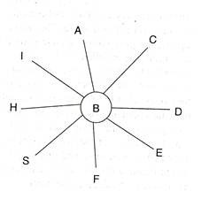](http://www.psychologydiscussion.net/wp-content/uploads/2016/02/clip_image002_thumb2-2.jpg)**

**1. Hard boiled autocrat:**

The hard boiled autocrat is very rigid and believes that praise will improve the members efficiency and loyalty in group. He is very much status conscious and does not usually trust the initiative of employees. Because of such behaviour the group members feel tensed, insecured, aggressive and egocentric.

**2. Benevolent autocrat:**

He dominates all members of the group. Here the members depend upon the leader for all decisions and demonstrate a slow regression to more submission, dependency and inability to take responsibility.

**Democratic Group:**

In democratic group the individual member has more responsibility and more scope for active participation in the functions of the group. In such a group every member is allotted some responsibility, some power, for which he feels great and involved. Different members know each other directly as the group members have link with each other.

Morale is high in democratic group as there is internal cohesion between the different members. Net pattern is said to be the most complex structure of a group.

## Types of Groups in Organizational Behavior (OB)

There can be many types of groups in organizations as they can be formulated by organization or employees. All such groups in organization can be classified into two broad categories as formal work groups and informal work group as below:

### A. Formal Work Group

Formal organization structure or managers formulate formal work groups to conduct different planned activities. The goals, leadership pattern, norms and values of such formal work groups are set on the basis of needs or organization. Formal group are again classified into command groups and task groups.

#### 1. Command Groups

Command groups are formed with employees reporting to the same supervisor. Such groups are represented on organizational charts frequently. Such groups are normally permanent in nature and play important role on the extent of organizational success.

#### 2. Task Force/Groups

Task forces are formed with the people with supplementary skills and experience to accomplish a specific task. Such groups are dissolved after accomplishment of specified goals. A standing committee or task groups are example of task forces which are permanent in nature though members may be changed.

### B. Informal Work Groups

Informal work groups are formed with the intention or effort of employees. Such groups are the results of perception of employees that 'membership in a group will help them achieve their goals or meet their needs.' Such informal groups are formed to fulfill their personal goals like to bargain for salary and benefits, to pass leisure time and to get refreshment. Informal groups can be further classified into two categories.

#### 1. Friendship Groups

Friendship groups are formed with the collection of employees who enjoy to each other. Such groups are formed on the basis of age, gender, geographic, area, ethnicity, etc. of employees involved in organization. Friendship groups can be extended beyond the organization.

#### 2. Interest groups

Interest groups are formed with employees having common goal or objective related to their organizational membership. Such groups are formed for the joint effort to achieve their common objectives.

## Work Group Behavior

Work groups in the organization are most important aspect of organizational success as their behavior affects on organizational performance. Various factors including external and internal affect on group behavior and performance.

### 1. External Conditions imposed on the group

Group behavior can be considered as input-output system, sub-system of organizational behavior system. This system interacts with external environment. Factors like organizational strategy, authority structure, formal regulations, organization resources, human resource selection process, performance evaluation and reward system, organizational culture, physical work settings, etc. from external environment affect the group behavior.

### 2. Group member resources

Abilities and personality characteristics of members of the group largely affect to the behavior and performance of group. Abilities are talents of group member to solve problems regarding job responsibilities. Personality characteristics affect the group interaction pattern, performance and job satisfaction level. Personality characteristics relate to trait, attitude and behavior.

### 3. Group structure

Group structure is characterized with various elements like formal leadership, roles, norms, group size, group status, degree of group cohesiveness. Group structure operates in physical and social setting. Success of the group largely depends upon the vision and leadership style.

*Role* of group member is a set of activities expected to perform in groups in order to attain group goals. In another words, roles are the expected behavior of group members for a position and job. Roles of individuals may be different and there can be role conflicts. Conflicts in roles are the result differences in role identity, role perception and role expectations.

*Norms* are standard rules shared by individual to observe or understand the reality. These are common understandings and rules to which each member is attached in group. Norms are dynamic in nature and hence norms are four classes as performance norms, appearance norms, social arrangement norms and allocation of resource norms.

*Status* is the importance given by hierarchical structure or position in group. Formally governed status remains more permanent in comparison to informal organization. Formal status is closely related to the chain of command whereas informal status can be acquired by such characteristics as education, age, gender, skills, experience, social membership; etc. Equitable distribution of status in the group motivates group members.

Next important element affecting group structure is *group size* and hence it will have greater impact on group behavior. It is responsible to determine individual interactions in group interaction. Researchers have identified 7 members groups is the ideal maximum size for decision making and 14 is the maximum for a fact finding group. Normally, small groups are more effective in comparison to large organization to complete group task. But, larger groups make more effective decisions while solving problems.

*Group cohesiveness* is another important factor affecting group structure and behavior. It is the degree of attachment so that each member confirms strictly to follow the group standard. It is the degree of feeling of unity within groups.

Cohesive groups contain the following characteristics:

* Such groups contain relatively few members.
* Members of cohesive groups have similar interest and background.
* Members have high degree of status within the organization.
* There is strong interpersonal communication and interdependency.
* Cohesive groups are physically remote or isolated from the other groups in the organization.
* Leaders reward for cooperative behavior.
* Groups are pressured or threatened by some common outside force, and
* They have history of past success.

### 4. Group processes

Each group contains input-processing-output-feedback mechanism within the organization. This means group contains group processes. Leadership, communication, power, conflicts, group’s decision making, authority, etc. are important variables of group processes. Process gain increases the effectiveness but processes loss decrease the effectiveness. In group, it is important to understand the group processes for the following reasons:  
  
i. Social loafing

Social loafing is the tendency of decreasing effort because of the group influence. Members think that other members contribute to the group effort so that there will be negligible effect of their performance. This explains a process loss as a result of group.

#### ii. Synergy

Synergy is the positive effect of group performance producing additional performance greater than just a arithmetic sum of individual effort. This means by working in a group, it results whole which is greater than sum of parts. This explains process gain.

#### iii. Social facilitation effect

It is the tendency of improving or declining the performance in presence of other. Some people speed up their task while working with or in front of other while some other decrease the speed up to show the complexity.

### 5. Group task

Task is defined as the work activity designed to be performed under a job responsibility. Work group is based on the task interdependence. Complexity of tasks of work group largely affect of the performance and satisfaction of group. Number of group member should be determined on the basis of complexity, variation in task or content of task.

## Nature and Significance of Informal Groups

Informal work groups are formed spontaneously with the intention or effort of employees. Such informal groups are formed to fulfill personal goals like to bargain for salary and benefits, to pass leisure time and to get refreshment. Informal groups can be further classified into two categories as friendship groups and interest groups. Informal groups though they are not formed with organizational purpose and have no fixed structure with roles, responsibilities and authority, are more important for organizational performance.

### Nature of informal group

Since, informal group are formed with common interests of employees in the organization. Such groups are formed because of similarity in age, gender, language, region, religion, culture, etc. Cohesiveness in informal group members is found strong though the leadership is not fixed. Informal groups possess following features:

* Groups are formed spontaneously and hence they are unplanned.
* Formation of informal groups is natural process reflecting human relationship.
* Group structure and leadership are not fixed.
* Membership of informal groups is voluntary.
* Members have common goals and interest. Person is focused rather than position.
* Group members use grapevine and informal channel of communication.
* Informal groups do not establish formal rules and regulations. They run by group norms, values and belief of group guide the behavior of member.
* Informal groups co-exist within formal group. In large formal groups, there is chance of formulation of many informal groups.
* Such groups can adapt environmental change.

### Significance of informal groups

Informal groups have significant role in organizational performance. Their significance can be discussed under following points:

#### 1. Sense of belongingness and security

Member of informal groups feel that they are safe because of the membership in group. This helps to fulfill security needs of human resources. This creates cohesiveness among members of group.

#### 2. Satisfaction

Employees share their feelings and ideas formally or informally in group. They entertain their work being the member of group. This increases the level of satisfaction of employees because of which employees can be protected from frustration and emotional problems.

#### 3. Reduced supervision

Informal group members have greater cohesive force for their objectives. They form group norms and values to attain group goals. This helps group member to motivate for group performance. Motivated employees support to management and hence reduce the supervision.

#### 4. Easy communication

Members in informal communication follow group norms and values strongly. They experience greater cohesion and connected in grapevine. This helps to communicate messages more effectively and efficiently.

#### 5. Authority check

Managers become sensitive in using authority in the organization because of synergy of knowledge level of member of informal groups. Thus informal groups act as the check for authority level.

#### 6. Social control

Informal groups exercise social control through norms and values. This helps to maintain acceptable behavior of employees in the organization.

#### 7. Improved personality

Members of group feel proud being member. They maintain self-image which helps to develop their personality.

#### 8. Innovation and development

Informal group members share ideas and experience more openly among the group members. They identify more effective methods for creating efficiency in operation. Their knowledge can be used to improve the operating system. Informal groups create congenial environment for development products.

#### 9. Organizational performance

Informal groups can be used to improve organizational performance. Their creativity, skills and coordinated efforts can produce positive synergy.

## Issues Related to Group Decision Making (GDM)

As, mentioned earlier, there can be different types of groups. Such groups make decisions for organization or for group’s purpose. Their decisions affect both individual and organization. It is essential to estimate the effect i.e. positive or negative. Negative effects need to minimize for which various techniques need to establish in organization. Several critical issues are emerged in group decision making. Some of them are discussed below:

### 1. Issue of group polarization (Shift)

In group decision making, issue of group polarization is being more importantly emerging. Polarization is the tendency of dividing the group members for different issues in decision. This can be simply understood as grouping of members in decision with opposite opinion. This may occur before the decision making, after the decision making, and after the decision.

#### i. 'X types of orientation'

Before joining the meeting i.e. before group decision making, every member may be convinced in improving the quality of goods and service. There is no polarization.

#### ii. 'Y types of Orientation'

During meeting i.e. group decision making, they may be taking the position for no, yes or how? What other companies are doing? There is still no polarization.

#### iii. 'Z types of orientation'

After the group decision making process, group member may be divided in strategy. There can be two types of polarization i.e. polarization 'A' and polarization 'B'. In polarization 'A', decision maker may put their version for selling at the same price with improved quality, new packaging and new technology. They will be ready to bear further loss for future benefit. This is conservative shift opinion. While in polarization 'B', members may put their vision for increasing quality along with price. More investment can be made in advertisement. They argue if this project can be dropped with new products if the loss from current product continues.

### 2. Issue of time constraints

Another common issue in GDM is that group members waste hours for discussion but make the decision at the influence of single or minimum number of members. Group members is most of time do not make decision because of lack of understanding. To make consensus, they take remarkable time producing little output.

### 3. Issue of group think

Group think is the tendency of making decision on the basis of majority or seniority of the group member. Minority or less influential members are pressurized to approve or confirm the decision. Group members will have no sufficient time for thinking and evaluating unusual, minority and unpopular arguments or views. Group think occur when time pressure for decision is intense to the directive leaders in cohesive groups. Such decision result less productive outcome.

### 4. Issue of cost and advantages

Group decision making process incurs cost. Cost of accommodation, refreshment, transportation, allowances, and other benefits are direct cost incurring to such GDM. If properly made, decision from such group discussion can be more productive. But, the issue is 'how to reduce the cost of GDM and increase the advantages?'

### 5. Issue of participation

In most of cases, members participated physically just to fulfill quorum in the meeting. They do not psychologically participate either because of hesitation, or because of unwillingness. This is the issue of decision making and implementation as well. Power sharing i.e. the issue of centralization and decentralization is another important issue because of which real participation may be affected. Similarly, sometimes, decision are made only for formality but they are not implemented accurately which discourages in participating psychologically.

|  |  |  |
| --- | --- | --- |
| **(A)**  **Members**  **Groups**  These are groups to which an individual actually belongs. For example Bharatiya Kamgar Sangh | **(B)**  **Reference Groups** These are groups to which the individual aspires to belong to for instance, the Gymkhana Club, The Rotary Club etc. | **In groups**  These represent a clustering of individual holding a dominant place in the society in terms of power structure with it patterns of behaviour considered desirable **(C)** |
| **Interest groups** These represent individuals who affiliate to attain a particular objective. For instance, employees who join together to get their vacations altered, or seek improved working conditions etc.  **(F)** | **Friendship Groups** They come together because they share one or more common characteristics. Like social alliances outside work place based on similar age or religious binding and so on.  **(E)** | **The Out-Group (D)**  It is the conglomerate usually referred to as a minority group though in certain instances it may represent a numerical majority |

## Types of Conflict

There are several [**common causes of conflict at work**](https://www.highspeedtraining.co.uk/hub/conflict-management-in-the-workplace/), but most are categorised by who in the workplace is involved in it.

#### The 4 main categories are:

* **Intrapersonal** – this is when a person experiences inner turmoil, such as disagreeing with the values of the company or being a perfectionist.
* **Interpersonal** – this is conflict between two or more individuals; it may be an isolated incident or an ongoing issue.
* **Intragroup** – this refers to the conflict between one or more people in the same group or team.
* **Intergroup** – these involve several different teams and are often difficult to handle without external support or preventative/corrective action.

**Group Conflict** The most common problems for students using group work in the classroom are an absence of leadership and coordination, an inability to communicate effectively, difficulty defining and assigning tasks, trouble maintaining equal participation, and frustration with setting and achieving group goals.

The most **common causes** of conflict within groups are:

• Faulty communication: criticism is given inappropriately, and group members’ feelings are hurt and they feel devalued

• Attribution errors: members make errors in determining the causes of the behavior of other members. This can occur, for example, when one member doesn’t complete his or her work and the other members jump to the conclusion that the reason for this was nothing more than irresponsibility. Maybe there was a good reason why that one member fell behind.

• Mistrust: members do not trust each other due to poor communication, faulty attributions, or someone’s lack of follow through on obligations

• Grudges: members hold grudges when they feel they have been treated unfairly, when criticism has been given inappropriately, when there have been faulty attributions, or for other reasons; people become angry with each other and they sometimes nurse their anger and remain hostile rather than working through and resolving their anger and moving on.

• Personality clashes: this can occur when groups are put together randomly in particular. The styles of working differ with each member and in some cases; there may be a lack of fit among the members”

**Conflict Resolution**

“Conflict in a group doesn’t have to mean that the group cannot function. In fact, if the conflict is handled well, it may actually help the group to function.

Some conflict resolution methods that you can present to your students when dealing with group conflict:

1. Deal with each conflict as it arises. Do not try to ignore it, hoping it will go away—it will probably fester and become worse if not dealt with. Let’s use the example of one person in a group working at a very slow pace that is holding up the work of other group members.

2. Present the conflict as evidence that people are involved and excited about their work, and that they are showing a passionate commitment to what they are doing. This may involve a little situational reconstruction to enable everyone to view what has been a negative situation as an opportunity for positive outcomes. For example, note that while the group may be frustrated with one member’s slow work, the frustration reflects the enthusiasm of the group and the slowness may indicated the painstaking effort and care of the slow group member.

3. Confront the issue as a problem to be solved. Focus on working together to solve the problem. In the example noted above, the issue would be how to enable the slow worker to be faster, providing what the rest of the group needs without losing the care that he or she has been taking

4. Do not engage in blaming or character assassination. In the above example, blaming the slow worker or calling the slow worker derogatory names is strictly prohibited.

5. Be open-minded and fair, listening to all sides of the issue. Why does the slow worker say he or she is slow?

6. Insist on criticism being given appropriately and constructively. Explain the problems that slowness has been causing and how it is making the group members feel.

7. Make sure everyone in the group understands all sides of the issue by having them repeat or write down what they believe the arguments to be. Then check to make sure that everyone is correct in their understanding.

Does the slow worker realize why the group is having problems with his or her slowness? Does the group understand why the slow worker is taking so much time?

8. Brainstorm to find solutions or compromises. Perhaps the slow worker’s job is actually bigger than it seems and could be broken into sub-parts with another member helping. Perhaps the slow worker could filter parts of his or her work to the group as each part is ready, rather than waiting for the entire task to be done

**GROUP COHESIVENESS**

Groups differ in their cohesiveness that is the degree to which members are attracted to each other and are motivated to stay in the group. Cohesiveness is important as it is linked to group’s productivity.

Relationship between Group Cohesiveness and productivity can better be shown as:

***HIGH LOW***

|  |  |  |
| --- | --- | --- |
| High productivity | Moderate productivity | ***LOW*** |
| Low productivity | Moderate to low productivity | ***HIGH*** |

**Module II:**

Following are the main roles of a leader in an organization:

1. **Required at all levels-** Leadership is a function which is important at all [levels of management](https://managementstudyguide.com/management_levels.htm). In the top level, it is important for getting co-operation in formulation of plans and policies. In the middle and lower level, it is required for interpretation and execution of plans and programmes framed by the top management. Leadership can be exercised through guidance and counseling of the subordinates at the time of execution of plans.
2. **Representative of the organization-** A leader, i.e., a manager is said to be the representative of the enterprise. He has to represent the concern at seminars, conferences, general meetings, etc. His role is to communicate the rationale of the enterprise to outside public. He is also representative of the own department which he leads.
3. **Integrates and reconciles the personal goals with organizational goals-** A leader through leadership traits helps in reconciling/ integrating the personal goals of the employees with the organizational goals. He is trying to co-ordinate the efforts of people towards a common purpose and thereby achieves objectives. This can be done only if he can influence and get willing co-operation and urge to accomplish the objectives.
4. **He solicits support-** A leader is a manager and besides that he is a person who entertains and invites support and co-operation of subordinates. This he can do by his personality, intelligence, maturity and experience which can provide him positive result. In this regard, a leader has to invite suggestions and if possible implement them into plans and programmes of enterprise. This way, he can solicit full support of employees which results in willingness to work and thereby effectiveness in running of a concern.
5. **As a friend, philosopher and guide-** A leader must possess the three dimensional traits in him. He can be a friend by sharing the feelings, opinions and desires with the employees. He can be a philosopher by utilizing his intelligence and experience and thereby guiding the employees as and when time requires. He can be a guide by supervising and communicating the employees the plans and policies of top management and secure their co-operation to achieve the goals of a concern. At times he can also play the role of a counselor by counseling and a problem-solving approach. He can listen to the problems of the employees and try to solve them.

**Theories of leadership**

**Trait Theory**

The trait theory seeks to determine the personal characteristics or traits of a successful leader. A successful leader is supposed to have the following traits: good personality, intellectual ability, initiative, imagination, emotional stability, desire to accept responsibility, flexibility, honesty, sincerity, integrity, ability to make quick decisions, courage, reliability, persuasive power, etc. To determine the personality traits of a successful leader, studies were conducted by selecting successful leaders and find out their traits. It was presumed that persons possessing these traits could become successful leaders.

Among the core traits identified are:

* *Achievement drive:* High level of effort, high levels of ambition, energy and initiative
* *Leadership motivation:* an intense desire to lead others to reach shared goals
* *Honesty and integrity:* trustworthy, reliable, and open
* *Self-confidence:* Belief in one’s self, ideas, and ability
* *Cognitive ability:* Capable of exercising good judgment, strong analytical abilities, and conceptually skilled
* *Knowledge of business:* Knowledge of industry and other technical matters
* *Emotional Maturity:* well adjusted, does not suffer from severe psychological disorders.
* *Others:* charisma, creativity and flexibility

**Behavioural Theory of Leadership**

In this approach, the emphasis is on the actual behaviour and action of the leaders and not on their traits or characteristics. In other words, this approach emphasises that strong leadership is the result of effective role behaviour.

This approach states that the leader uses three skills to lead his followers. These skills are: technical (refers to a person's knowledge of the process of technique), human (refers to ability to interact with people and conceptual (refers to manager's ideas which enable a manager to set up models and design plans).

This approach assumes that a particular behaviour of a manager will make him a good leader while its opposite would discard him as a leader. Determining goals, motivating employees for achieving the goals, effective communication ability to interact effectively, building team spirit, etc. are the functional behaviour of a successful leader.

This theory emphasises the point that the favourable behaviour of a leader provides greater satisfaction to the followers and they recognise him as their leader. However, one limitations of this approach is that a particular behaviour and action of a leader may be relevant and effective at a particular point of time while at another, it may be irrelevant and ineffective. Thus, in this approach, the 'time' factor which is a vital element has not been considered.

**Situational Theory**

According to this theory, leadership is affected by a situation from which a leader emerges and in which he works. In other words, the situation — the group, the problem and its environment — will affect the type of leadership. An important aspects of this theory is the interaction between the group and its leader and the people tend to follow the person who is capable of fulfilling their desires.

The leader recognises his followers' desires and follows such methods (depending on the situation) which satisfy them. In other words, situational theory emphasises that there is no one best style of leadership universally applicable to all situations and that the leader has to change his style of leadership from situation to situation. If the leader adopts the same style under all situations, he may not be successful. For example, Winston Churchill was the most effective and successful Prime Minister of Britain during the period of the Second World War, but he was a flop afterwards when the situation changed.

**Managerial Grid Model of Leadership Explained**

Developed by R. R. Blake and J. S. Mouton

They identified five [**basic leadership styles**](http://iedunote.com/how-leadership-works-in-an-organization) of practicing managers representing various combinations of the aforesaid two dimensions as shown in the following figure;

Managerial Grid Model is based on two behavioral dimensions:

1. **Concern for people:** This is the degree to which a leader considers the needs of team members, their interests, and areas of personal development when deciding how best to accomplish a task.
2. **Concern for production:** This is the degree to which a leader emphasizes concrete objectives, organizational efficiency, and high productivity when deciding how best to accomplish a task.

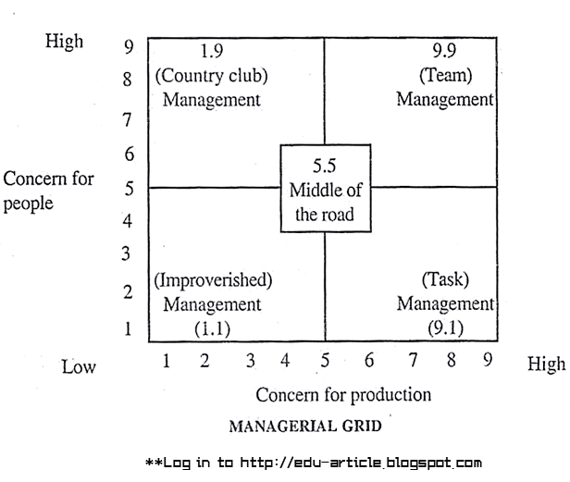

# Ohio State Leadership Studies Explained with Examples

Ohio State Leadership Studies is [**Behavioral Leadership Theory**](http://iedunote.com/behavioral-theory-of-leadership). Series of studies on [**leadership**](https://iedunote.com/how-leadership-works-in-an-organization) was done by the Ohio State University in 1945 to identify observable behaviors of [**leaders**](http://iedunote.com/characteristics-of-charismatic-leader) instead of focusing on their individual traits.

Ultimately, these studies narrowed the description of leader behavior into two dimensions:

1. **Initiating Structure Behavior:**The behavior of leaders who define the leader-subordinate role so that everyone knows what is expected, establish formal lines of communication, and determine how tasks will be performed.
2. **Consideration Behavior:** The behavior of leaders who are concerned for subordinates and attempt to establish a worm, friendly, and supportive climate.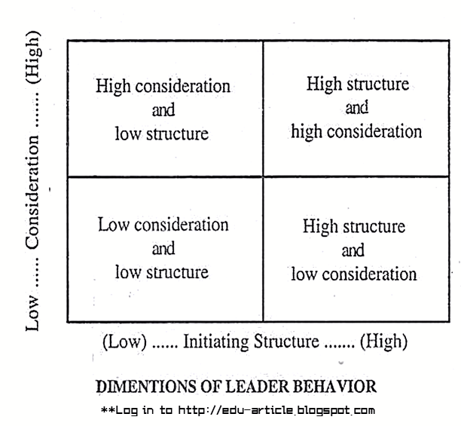

# Michigan Leadership Studies: Behavioral Leadership Theories

Michigan Leadership Studies is a [**behavioral Leadership Theory**](https://iedunote.com/behavioral-leadership-theories) that indicates the Institute for Social Research at the University of Michigan conducted empirical studies to identify styles of [**leader**](https://iedunote.com/charismatic-leader-characteristics) behavior that results in higher performance and satisfaction of a group.

The studies identified two distinct styles of leadership;

1. **Job-centered Leadership:** Managers using job-centered leader behavior pay close attention to subordinates’ work, explain work procedures and are keenly interested in performance.
2. **Employee-centered Leadership:** Managers using employee- centered leader behavior are interested in developing a cohesive work group and ensuring that employees are satisfied with their jobs. The Michigan Leadership Studies found that both the styles of leadership led to increase in production, but it was slightly more in case of production of job-centered style.

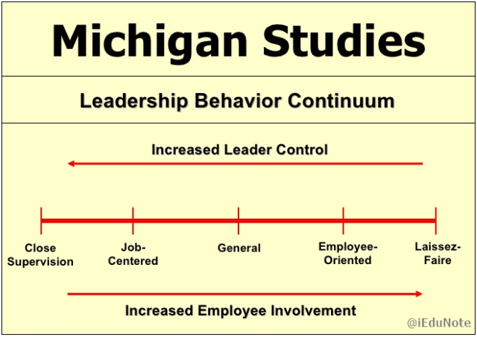

However, the use of direct pressure and close supervision led to decreased satisfaction and increased turnover and absenteeism.

The employee-centered approach led to the improved work-flow procedure and more cohesion in interactions resulting in increased satisfaction and decreased turnover and absenteeism.

This suggested the superiority of the employee-centered leadership style.

.

# 12 Different Types of Leadership Styles

Some leaders cannot work comfortably with a high degree of followers’ participation in decision making. Some employers lack the ability or the desire to assume responsibility. Furthermore, the specific situation helps determine the most effective style of interactions. Sometimes leaders must handle problems that require immediate solutions without consulting followers.

**Different Leadership Styles**

1. **Autocratic Leadership**

Autocratic leadership style is centered on the boss. In this leadership the leader holds all authority and responsibility. In this leadership, leaders make decisions on their own without consulting subordinates. They reach decisions, communicate them to subordinates and expect prompt implementation. Autocratic work environment does normally have little or no flexibility.

In this kind of leadership, guidelines, procedures and policies are all natural additions of an autocratic leader. Statistically, there are very few situations that can actually support autocratic leadership.

Some of the leaders that support this kind of leadership include: Albert J Dunlap (Sunbeam Corporation) and Donald Trump (Trump Organization) among others.

### 2. Democratic Leadership

In this leadership style, subordinates are involved in making decisions. Unlike autocratic, this headship is centered on subordinates’ contributions. The democratic leader holds final responsibility, but he or she is known to delegate authority to other people, who determine work projects.

The most unique feature of this leadership is that communication is active upward and downward. With respect to statistics, democratic leadership is one of the most preferred leadership, and it entails the following: fairness, competence, creativity, courage, intelligence and honesty.

### 3. Strategic Leadership Style

Strategic leadership is one that involves a leader who is essentially the head of an organization. The strategic leader is not limited to those at the top of the organization. It is geared to a wider audience at all levels who want to create a high performance life, team or organization.

The strategic leader fills the gap between the need for new possibility and the need for practicality by providing a prescriptive set of habits.  An effective strategic leadership delivers the goods in terms of what an organization naturally expects from its leadership in times of change. 55% of this leadership normally involves strategic thinking.

### 4. Transformational Leadership

Unlike other leadership styles, transformational leadership is all about initiating change in organizations, groups, oneself and others.

Transformational leaders motivate others to do more than they originally intended and often even more than they thought possible. They set more challenging expectations and typically achieve higher performance.

Statistically, transformational leadership tends to have more committed and satisfied followers. This is mainly so because transformational leaders empower followers.

### 5. Team Leadership

Team leadership involves the creation of a vivid picture of its future, where it is heading and what it will stand for. The vision inspires and provides a strong sense of purpose and direction.

Team leadership is about working with the hearts and minds of all those involved. It also recognizes that teamwork may not always involve trusting cooperative relationships. The most challenging aspect of this leadership is whether or not it will succeed. [According to Harvard Business Review](https://hbr.org/2009/05/why-teams-dont-work), team leadership may fail because of poor leadership qualities.

### 6. Cross-Cultural Leadership

This form of leadership normally exists where there are various cultures in the society. This leadership has also industrialized as a way to recognize front runners who work in the contemporary globalized market.

Organizations, particularly international ones require leaders who can effectively adjust their leadership to work in different environs. Most of the leaderships observed in the United States are cross-cultural because of the different cultures that live and work there.

### 7. Facilitative Leadership

Facilitative leadership is too dependent on measurements and outcomes – not a skill, although it takes much skill to master. The effectiveness of a group is directly related to the efficacy of its process. If the group is high functioning, the facilitative leader uses a light hand on the process.

On the other hand, if the group is low functioning, the facilitative leader will be more directives in helping the group run its process. An effective facilitative leadership involves monitoring of group dynamics, offering process suggestions and interventions to help the group stay on track.

### 8. Laissez-faire Leadership

Laissez-faire leadership gives authority to employees. According to azcentral, departments or subordinates are allowed to work as they choose with minimal or no interference. According to research, this kind of leadership has been consistently found to be the least satisfying and least effective management style.

### 9. Transactional Leadership

This is a leadership that maintains or continues the status quo. It is also the leadership that involves an exchange process, whereby followers get immediate, tangible rewards for carrying out the leader’s orders. Transactional leadership can sound rather basic, with its focus on exchange.

Being clear, focusing on expectations, giving feedback are all important leadership skills. [According to Boundless.com](https://www.boundless.com/management/textbooks/boundless-management-textbook/leadership-9/types-of-leaders-72/key-behaviors-of-transactional-leaders-356-6822/), transactional leadership behaviors can include: clarifying what is expected of followers’ performance; explaining how to meet such expectations; and allocating rewards that are contingent on meeting objectives.

### 10. Coaching Leadership

Coaching leadership involves teaching and supervising followers. A coaching leader is highly operational in setting where results/ performance require improvement. Basically, in this kind of leadership, followers are helped to improve their skills. Coaching leadership does the following: motivates followers, inspires followers and encourages followers.

### 11. Charismatic Leadership

In this leadership, the charismatic leader manifests his or her revolutionary power. Charisma does not mean sheer behavioral change. It actually involves a transformation of followers’ values and beliefs.

Therefore, this distinguishes a charismatic leader from a simply populist leader who may affect attitudes towards specific objects, but who is not prepared as the charismatic leader is, to transform the underlying normative orientation that structures specific attitudes.

### 12. Visionary Leadership

This form of leadership involves leaders who recognize that the methods, steps and processes of leadership are all obtained with and through people. Most great and successful leaders have the aspects of vision in them.

However, those who are highly visionary are the ones considered to be exhibiting visionary leadership. Outstanding leaders will always transform their visions into realities

**Difference Between Transactional and Transformational Leadership**

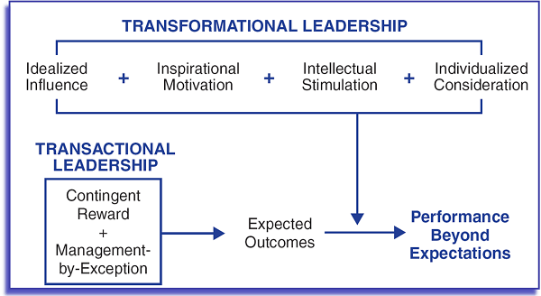

Transactional leaders handle all the details that come together to build a strong reputation in the marketplace while keeping employees productive on the front line.

Transformational leadership styles are crucial to the strategic development of a small business.

Small businesses with transformational leaders at the helm shoot for ambitious goals, and can they achieve rapid success through the vision and team-building skills of the leader.

|  |  |
| --- | --- |
| **Transactional Leadership** | **Transformational Leadership** |
| Leadership is responsive | Leadership is proactive |
| Works within the organizational culture. | Works to change the organizational culture by implementing new ideas. |
| Employees achieve objectives through rewards and punishments set by the leader. | Employees achieve objectives through higher ideals and moral values. |
| Motivates followers by appealing to their own self-interest. | Motivates followers by encouraging them to put group interests first. |
| Management-by-exception: maintain the status quo; stress correct actions to improve performance. | **Individualized consideration**  Each behavior is directed to each individual to express consideration and support. |
| Intellectual stimulation or motivation is zero. | **Intellectual stimulation**  Promote creative and innovative ideas to solve problems. |

**SPARKLE model**

**Leadership** can be defined as the will to control events, the understanding to chart a course, and the power to get a job done, while cooperatively using the skills and abilities of other people.

The SPARKLE Principles are defined as follows:

**Self-Discipline** means that a leader tends to live by a set of rules or principles that he determines are appropriate for him and acceptable to his constituents. A leader does not need external motivation to ensure performance.

**Purpose** means that a leader develops intense determination to achieve his vision and his objectives. Intense determination creates high morale and spirit among constituents. This allows the leader to effectively employ both personal and organizational power to accomplish goals. The leader uses this power to direct and control the efforts of his followers.

**Accomplishment** means that a leader defines results in terms of meeting the needs of his constituents. Successful results are the foundation of leadership. Taking effective action is the basis for successful results. The elements of effective action are decision, determination, energy, simplicity, balance, and chance.

**Responsibility** means that a leader embraces the duties and obligations that grow from the trust and power given him. The most critical of these obligations are clear perception, determined action, and an overriding concern for the best interests of him constituents. A strong leader owns up to the results of his decision and actions and shares their consequences along with his constituents.

**Knowledge** is the foundation of successful leadership. Knowledge has three aspects. The first, fundamental knowledge, deals with studying science, history, and human nature; in other words, learning the basics of the art of leadership. The second, strategic knowledge, concerns understanding the needs and goals of both constituents and competitors and planning effective operations to reach objectives. The third, tactical knowledge, focuses on uncovering evolving threats and opportunities and responding swiftly and appropriately to them, within the strategic framework, through innovation and improvisation.

**‘Ladder’-ship** means that a leader understands the special nature of the social and moral contract between leaders and their constituents. The leader is dependent upon his followers for his power and, to a large extent, his ability to produce results. Therefore, he must work cooperatively with them to reach agreed-upon objectives. But, at the same time, strong leadership is one of the more important factors, if not the only absolutely necessary one, in the success of those human activities that depend upon cooperation. Therefore, a leader is charged the responsibility of imposing, through the exercise of appropriate power, whatever level of order and discipline is required to meet objectives. He does this in part by using a system of rewards and penalties that is perceived as fair and just by his constituents.

**Team**

A group of people with a full set of complementary skills required to complete a task, job, or project.  
Teams members (1) operate with a high degree of interdependence, (2) share authority and responsibilities for self-management, (3) are accountable for the collective performance, and (4) work toward a common goal and shared rewards(s). A team becomes more than just a collection of people when a strong sense of mutual commitment creates synergy, thus generating performance greater than the sum of the performance of its individual members.

**Characteristics of Effective Team** 

1. **There is a clear unity of purpose.**   
   There was free discussion of the objectives until members could commit themselves to them; the objectives are meaningful to each group member.   
     
   **2. The group is self-conscious about its own operations.**  
   The group has taken time to explicitly discuss group process -- how the group will function to achieve its objectives. The group has a clear, explicit, and mutually agreed-upon approach: mechanics, norms, expectations, rules, etc. Frequently, it will stop to examined how well it is doing or what may be interfering with its operation. Whatever the problem may be, it gets open discussion and a solution found.   
     
   **3. The group has set clear and demanding performance goals**  
   for itself and has translated these performance goals into well-defined concrete milestones against which it measures itself. The group defines and achieves a continuous series of "small wins" along the way to larger goals.   
     
   **4. The atmosphere tends to be informal, comfortable, relaxed.**  
   There are no obvious tensions, a working atmosphere in which people are involved and interested.   
     
   **5. There is a lot of discussion in which virtually everyone participates,**  
   but it remains pertinent to the purpose of the group. If discussion gets off track, someone will bring it back in short order. The members listen to each other. Every idea is given a hearing. People are not afraid of being foolish by putting forth a creative thought even if it seems extreme.   
     
   **6. People are free in expressing their feelings as well as their ideas.**   
     
   **7. There is disagreement and this is viewed as good.**  
   Disagreements are not suppressed or overridden by premature group action. The reasons are carefully examined, and the group seeks to resolve them rather than dominate the dissenter. Dissenters are not trying to dominate the group; they have a genuine difference of opinion. If there are basic disagreements that cannot be resolved, the group figures out a way to live with them without letting them block its efforts.   
     
   **8. Most decisions are made at a point where there is general agreement.**  
   However, those who disagree with the general agreement of the group do not keep their opposition private and let an apparent consensus mask their disagreement. The group does not accept a simple majority as a proper basis for action.   
     
   **9. Each individual carries his or her own weight,**  
   meeting or exceeding the expectations of other group members. Each individual is respectful of the mechanics of the group: arriving on time, coming to meetings prepared, completing agreed upon tasks on time, etc. When action is taken, clears assignments are made (who-what-when) and willingly accepted and completed by each group member.   
     
   **10. Criticism is frequent, frank and relatively comfortable.**  
   The criticism has a constructive flavor -- oriented toward removing an obstacle that faces the group.   
     
   **11. The leadership of the group shifts from time to time.**  
   The issue is not who controls, but how to get the job done.

### Common Teams in Organizations

Three common types of teams include functional or departmental, cross-functional, and self-managing.

**Functional or Departmental Teams-**Groups of people from the same work area or department who meet on a regular basis to analyze customer needs, solve problems, provide members with support, promote continuous improvement, and share information.

These are the teams you're probably the most familiar with in the workplace. You may not even use the termteam. Instead, you call it a department but it's really a team. The members work together to accomplish a goal.

Working together doesn't necessarily mean that there is constant interaction between team members. For example, in an employee relations team, you may have seven employee relations specialists who support seven different departments (or other teams).

They may work very independently. But, a good team shares successes to help team members build best practices. A good team also shares failures so that the other team members can learn and help develop solutions.

**Cross-Functional Teams-**Groups of people who are pulled together from across departments or job functions to deal with a specific product, issue, customer problem, or to improve a particular process are cross-functional teams.

This team would consist of representatives from human resources, finance, legal, the executive team, and employees from affected areas.

Each person comes with a different responsibility and a needed contribution. For instance, legal is concerned with compliance, finance is concerned with budgets, and HR wants to ensure that the best people are retained.

**Self-Managing Teams-**Groups of people who gradually assume responsibility for self-direction in all aspects of work is called [self-managing teams](https://www.thebalancecareers.com/how-to-build-a-teamwork-culture-1918509).

**For effective team management, it is important that the team leader is more of a mentor to his team members rather than just being a strict boss**.

* Communication among the team members must be clear and transparent for an effective team management. **Every team member should get the same information and should have an easy access to the superiors in case of any query**.
* **The team members must not pass on any information to anyone outside the team**. Learn to keep things to yourself. It is unethical to share your professional secrets with others. Don’t leak information or any confidential data.
* **The team members must be motivated on a regular basis**. Appreciation is a must. If any team member has performed extraordinarily, do give him a pat on his back. Performance appraisals, perks, incentives, trophies, prizes are all instrumental in motivating the team members to perform even better the next time. Avoid criticizing any of your team members.
* **Loose talks, blame games, dirty politics should find no place in the team**. They spoil the environment and people lose interest in their work and organization. If you come to know anything about someone, it’s better to discuss with him face to face, else ignore.
* It is easy to create a team but it is actually difficult to bind the team members together and even make them work. Team management techniques help in strengthening the bond among the employees and creating an environment where they can trust each other.

Teams can be formed anywhere, anytime whenever the task is little difficult and complicated.

1. **Permanent teams-** These teams perform on a permanent basis and are not dissolved once the task is accomplished.

They were primarily responsible for promoting their brand and designing marketing strategies to generate maximum revenue for their organization. They worked extremely hard and always managed to achieve their targets well in advance, but their team was always in place and never dissolved. Their organization never asked them to leave or ever dissolved their team. Such teams are called permanent teams.

Work or no work, the human resources team, operation team, administration team always function effectively throughout the year and hence are permanent teams.

1. **Temporary teams -** Unlike permanent teams, temporary teams lose their importance, once the task is accomplished. Such teams are usually formed for a shorter duration either to assist the permanent team or work when the members of the permanent team are busy in some other project.

When organizations have excess of work, they generally form temporary teams which work in association with the members of the permanent team for the accomplishment of the task within the stipulated time.

1. **Task Force -** Such teams are formed for a special purpose of working on any specific project or finding a solution to a very critical problem.

The government generally appoints special teams to investigate critical issues like bomb blasts, terrorist attacks and so on. The task force explores all the possible reasons which led to a severe problem and tries to resolve it within a given deadline.

1. **Committee -** Committees are generally formed to work on a particular assignment either permanently or on a temporary basis. Individuals with common interests, more or less from the same background, attitudes come together on a common platform to form a committee and work on any matter.

To organize any cultural event, organizations generally make committees to raise funds, invite celebrities and all the major tasks involved to successfully organize any event. The committee members work together, design strategies to successfully accomplish the task.

1. **Organization/Work Force -** Such groups are formed in organizations where team members work together under the expert guidance of leader. A leader or a supervisor is generally appointed among the members itself and he along with his team works hard to achieve a common goal. The leader all through must stand by his team and extract the best out of each team member.
2. **Self Managed Teams -** Self Managed Teams consist of individuals who work together again for a common purpose but without the supervision of any leader. Here as the name suggests every individual is accountable for his individual performance. The team members of self managed teams must respect each other and should never lose focus on their target. No leader is appointed and the team members have to take their own responsibility. Individuals take the initiative on their own and are their own guides and mentors.
3. **Cross Functional Team-** Individuals from different areas come and work together for a common objective to form a cross functional team. In such teams, people from different areas, interests and likings join hands to come out with a unique idea to successfully complete a task.
4. **Virtual Teams -** Virtual teams consist of individuals who are separated by distances and connected through computer. Such teams are helpful when employees need to connect with each other and are located at different places. Individuals supporting any community in social networking sites such as facebook also form a virtual team as all the members are from different locations but support a common community.

**Power** means many different things to different people. For some, power is seen as corrupt. For others, the more power they have, the more successful they feel. For even others, power is of no interest at all.

**Formal Power**

Coercive

Coercive power is conveyed through fear of losing one’s job, being demoted, receiving a poor performance review, having prime projects taken away, etc. This power is gotten through threatening others. For example, the VP of Sales who threatens sales folks to meet their goals or get replaced.

Reward

Reward power is conveyed through rewarding individuals for compliance with one’s wishes. This may be done through given bonuses, raises, a promotion, extra time off from work, etc. For example, the supervisor who provides employees comp time when they meet an objective she sets for a project.

Legitimate

Legitimate power comes from having a position of power in an organization, such as being the boss or a key member of a leadership team. This power comes when employees in the organization recognize the authority of the individual. For example, the CEO who determines the overall direction of the company and the resource needs of the company.

**Personal Power**

Expert

Expert power comes from ones’ experiences, skills or knowledge. As we gain experience in particular areas, and become leaders in those areas, we begin to gather expert power that can be utilized to get others to help us meet our goals. For example, the Project Manager who is an expert at solving particularly challenging problems to ensure a project stays on track.

Referent

Referent power comes from being trusted and respected. We can gain referent power when others trust what we do and respect us for how we handle situations. For example, the Human

Resource Associate who is known for ensuring employees are treated fairly and coming to the rescue of those who are not.

**Empowerment:**

Empowerment means to give someone power or authority. In a customer support role that could mean allowing front line support providers the ability to make decisions that are exceptions to the rules like offering something to the customer that would not be normal, perhaps a concession if they have had a bad experience. By allowing front line support providers to make some exceptions, it saves valuable time for the customer and the company. It relieves the supervisor from having to be instantly available for decision making, it creates goodwill and customer satisfaction, and it allows the support provider to have some ownership in decisions. When customers realize that the support provider must continuously ask permission, the customer often bypasses the support person.

**Motivation**

**Maslow’s theory**

Maslow's hierarchy of needs is a motivational theory. Needs lower down in the hierarchy must be satisfied before individuals can attend to needs higher up. The first four levels are often referred to as deficiency needs (D-needs), and the top level is known as growth or being needs (B-needs).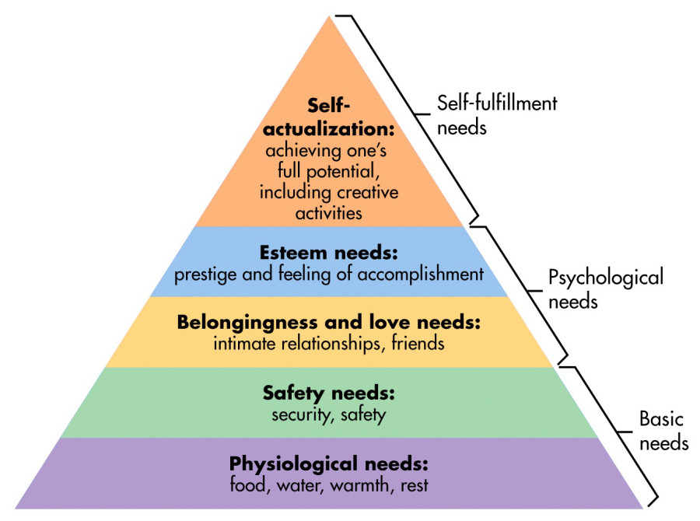

When a deficit need has been 'more or less' satisfied it will go away, and our activities become habitually directed towards meeting the next set of needs that we have yet to satisfy.

1. **Physiological needs** - these are biological requirements for human survival, e.g. air, food, drink, shelter, clothing, warmth, sex, sleep.

If these needs are not satisfied the human body cannot function optimally. Maslow considered physiological needs the most important as all the other needs become secondary until these needs are met.

2. **Safety needs** - protection from elements, security, order, law, stability, freedom from fear.

3. **Love and belongingness needs** - after physiological and safety needs have been fulfilled, the third level of human needs is social and involves feelings of belongingness. The need for interpersonal relationships motivates behavior

Examples include friendship, intimacy, trust, and acceptance, receiving and giving affection and love. Affiliating, being part of a group (family, friends, work).

4. **Esteem needs** - which Maslow classified into two categories: (i) esteem for oneself (dignity, achievement, mastery, independence) and (ii) the desire for reputation or respect from others (e.g., status, prestige).

Maslow indicated that the need for respect or reputation is most important for children and adolescents and precedes real self-esteem or dignity.

5. **Self-actualization needs** - realizing personal potential, self-fulfillment, seeking personal growth and peak experiences. A desire “to become everything one is capable of becoming”

Five-stage model has been expanded to include cognitive and aesthetic needs (Maslow, 1970a) and later transcendence needs

5. Cognitive needs - knowledge and understanding, curiosity, exploration, need for meaning and predictability.

6. Aesthetic needs - appreciation and search for beauty, balance, form, etc.

8. Transcendence needs - A person is motivated by values which transcend beyond the personal self (e.g., mystical experiences and certain experiences with nature, aesthetic experiences, sexual experiences, service to others, the pursuit of science, religious faith, etc.

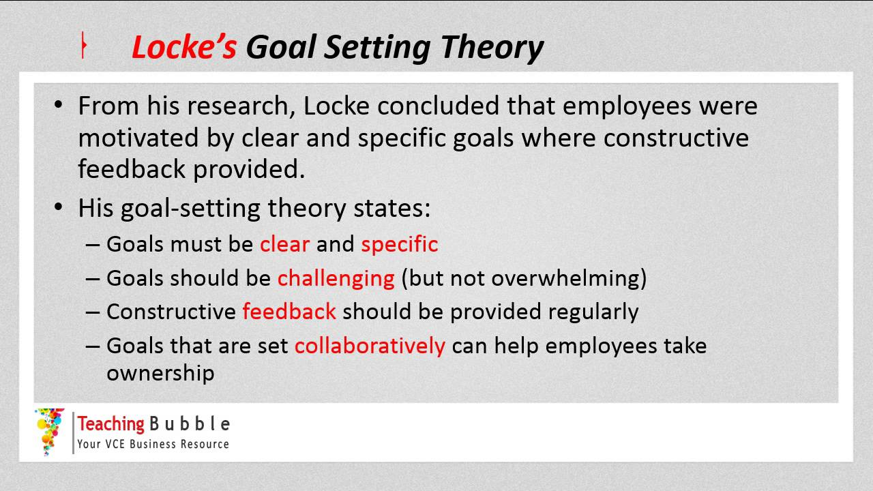

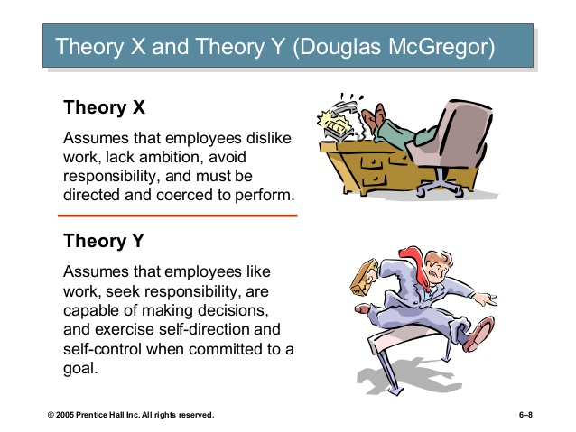

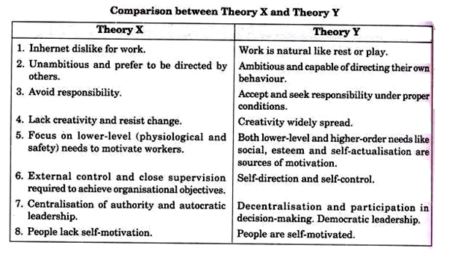

**Module -3**

Importance of Emotions

**Survival**

Nature developed our emotions over millions of years of evolution. As a result, our emotions have the potential to serve us today as a delicate and sophisticated internal guidance system. Our emotions alert us when natural human need is not being met. For example, when we feel lonely, our need for connection with other people is unmet. When we feel afraid, our need for safety is unmet. When we feel rejected, it is our need for acceptance which is unmet.

**Decision Making**

Our emotions are a valuable source of information. Our emotions help us make decisions. Studies show that when a person’s emotional connections are severed in the brain, he can not make even simple decisions. Why? Because he doesn’t know how he will feel about his choices.

**Predicting Behavior**

Our feelings are also useful in helping us predict our own, and others’ behavior.

**Communication**

Our emotions help us communicate with others. Our facial expressions, for example, can convey a wide range of emotions. If we look sad or hurt, we are signaling to others that we need their help. If we are verbally skilled we will be able to express more of our emotional needs and thereby have a better chance of filling them. If we are effective at listening to the emotional troubles of others, we are better able to help them feel understood, important and cared about.

**Happiness**

The only real way to know that we are happy is when we feel happy. When we feel happy, we feel content and fulfilled. This feeling comes from having our needs met, particularly our emotional needs. We can be warm, dry, and full of food, but still unhappy. Our emotions and our feelings let us know when we are unhappy and when something is missing or needed. The better we can identify our emotions, the easier it will be to determine what is needed to be happy.

**Positive Emotions Undo Negative Emotions**

Laboratory experiments have demonstrated that evoking positive emotions in these circumstances is the most efficient way to quell or "undo" the lingering aftereffects of negative emotions. Cultivating positive emotions speeds the return to cardiovascular normalcy. This undoing effect of positive emotions has been shown both for energized positive emotions like joy and amusement, and for tranquil positive emotions, like serenity and appreciation. The ability to cultivate positive emotions is thus an important skill for regulating negative emotions.

**Positive Emotions Fuel Resilience**

In part because positive emotions speed recovery from negative emotions they also fuel resilient coping. Resilient people, studies show, experience more positive emotions in the midst of adversity compared to those who are less resilient. These greater positive emotions, in turn, help resilient people bounce back to pre-crisis levels of functioning. Such findings suggest the timely cultivation of positive emotions is one way that people use emotions intelligently.

**Positive Emotions Broaden Thinking and Build Resources**

Positive emotions have important functions beyond alleviating negative emotions and fueling resilient coping, functions that have long been overlooked by scientists studying emotions. I spotlight these additional functions in my broaden-and-build theory of positive emotions. Positive Emotions Trigger Upward Spirals toward Optimal Functioning

Because positive emotions broaden thinking and build enduring psychological resources like resilience, they also trigger upward spirals toward enhanced emotional well-being.

**The Top 10 Characteristics of a Healthy Organization**

**Effective Sharing of Goals**

A healthy organization shares its business goals with employees at every level of the organization. Management shares goals with employees and gets them on board with the mission and vision of the organization. Employees and managers understand what is required to reach these shared goals and make every effort to achieve them.

**Teamwork**

Another characteristic is teamwork. Healthy companies know how to develop teams that collaborate to achieve common goals. Employees and managers readily offer their assistance to each other to meet corporate objectives.

**High Employee Morale**

Healthy organizations possess high employee morale. Employees value their positions in the organizations and desire to work there for a long time. Productivity is high and organizational events are enjoyable and successful.

**Offers Training Opportunities**

Companies provide on-the-job training and opportunities for employees to enhance their work-related skills. Organizations bring in other individuals to provide necessary departmental and corporate-wide training. Companies also offer opportunities to pursue certification and continual education.

**Leadership**

Good leadership is one of the main characteristics of a healthy organization. Employees have good relationships with management that are based on trust. Managers know how to get employees to function together. When correction is needed, employees readily accept the constructive criticism offered by leaders.

**Handles Poor Performance**

Companies confront poor performance instead of ignoring it. Organizations take corrective actions to improve performance. Upper-level management values the input of employees who make suggestions on how to improve productivity and achieve high performance rates. Companies may even bring in specialists to detect problems and offer solutions.

**Understanding Risks**

Healthy organizations understand the risks they are open to and take the necessary steps to protect themselves against them. When an event happens due to organizational risks, a healthy organization learns from the event. Companies use precaution but understand that risks are necessary to facilitate growth.

**Adapts to Opportunities and Changes**

Healthy organizations know how to recognize and seize good opportunities. Healthy organizations always look for opportunities to grow. They also know how to adapt to technological or operational changes.

**Clearly Defined Structure**

Companies possess a sense of order and organizational structure. The structure and order of the organization does not limit innovation and growth. Employees do not mind complying to the company's order because they understand it and see the benefits of its implementation.

**Well-Known Company Policies**

Organizations create and implement company policies that are readily available to their employees. Healthy organizations follow the policies and regulations of local, state and federal governments. When employees or managers break policies, the issue is dealt with immediately and in a professional manner.

**Happiness and Subjective Well-Being**

There are several reasons why the field of well-being is flourishing at the moment:

* First of all, Western countries have achieved a sufficient level of affluence, so that survival is no longer a central factor in people’s lives. Quality of life is becoming more important than matters of economic prosperity.

* Personal happiness is becoming more and more important because of growing trends towards individualism.

* Finally, a number of valid and reliable measures have been developed, which have allowed the study of well-being to establish itself as a serious and recognised discipline.

**SWB** = SATISFACTION WITH LIFE + AFFECT

The first, cognitive part of subjective well-being is expressed by life satisfaction. Life satisfaction represents one’s assessment of one’s own life. One is satisfied when there an ideal or deserved situation. On the other hand, dissatisfaction is a result of a substantial discrepancy between present conditions and the ideal standard. Dissatisfaction can also be a result of comparing oneself with others.

Affect represents the emotional side of SWB. The notion of affect comprises both positive and negative moods and emotions that are associated with our everyday experiences.

A number of theories say that it is impossible to permanently change someone’s level of happiness. One of these theories, the so-called ‘Zero-sum’, says that happiness is cyclical and that happy and unhappy periods follow each other. Any attempt to increase happiness will soon be nullified by a consequent unhappy period. Another theory claims that happiness is a fixed characteristic and is, therefore, not open to change, although happiness is not quite as stable during adolescence and early adulthood and can be affected by major life changes. Therefore, it is more likely that happiness ‘tends to get’ fixed, rather than being fixed from the very beginning.

Adaptation theory predicts that although happiness reacts at negative and positive life events, it returns to its baseline shortly afterwards. Lottery winners soon revert to their normal level of well-being, and paraplegics and quadriplegics also seem to adjust to their conditions and nearly come back to their previous level of well-being. It has been discovered that only life events which occurred during the past two or three months influence well-being. However, despite the evidence that people get adjusted to both lottery winning and spinal injuries, there are certain conditions (such as widowhood, loneliness and injustice) to which people never adjust completely.

Happiness and relationships

Diener and Seligman in their study of exceptionally happy people (the upper 10% of 222 college students) found only one main difference between the happiest and the rest of the students. The very happy people had a rich and fulfilling social life. They spent the least time alone, had good relationships with friends and had a current romantic partner. They did not have fewer negative and more positive events, nor differed on the amount of sleep, TV watching, exercise, smoking, drinking, etc.

Marriage usually leads to a rapid increase in SWB, which, unfortunately, comes down after a while. However, it does not return to the starting point, but stays at a higher level than before. So marriage changes the set point of SWB, although this change is not large.

|  |  |
| --- | --- |
| **SWB is related to:** | **SWB is not really related to:** |
| Optimism | Age (although there are somewhat contradictory findings in this respect) |
| Extraversion | Physical attractiveness |
| Social connections, i.e. close friendships | Money (once the basic needs are met, the difference between the very rich & alright is negligible) |
| Being married (marriage still scores better than cohabiting, although the latter is picking up as a predictor of SWB in individualistic societies) | Gender (women are more often depressed but also more often joyful) |
| Having engaging work | Education level |
| Religion or spirituality | Having children (see the next page for further clarification) |
| Leisure | Moving to a sunnier climate (in fact, moving to Australia will increase your SWB only by 1-2 %) |
| Good sleep & exercise | Crime prevention |
| Social class (through lifestyle differences & better coping methods) | Housing |
| Subjective health (what you think about your health) | Objective health (what doctors say) |

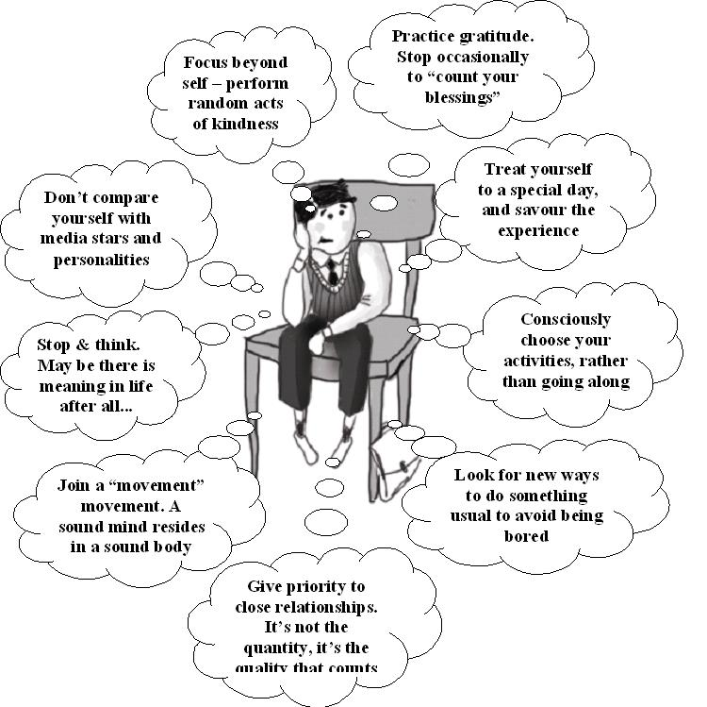

What Is **Work-life Balance**?

It’s always nice to have a little breathing space! In 1988, when I started formulating the concepts in my book, Breathing Space, whose subtitle is Living and Working at a Comfortable Pace in a Sped Up Society, I stumbled upon some insights that are still true to this day. In the first edition, published in 1990, as well as the latest edition, I discuss five overarching trends – what I called “mega-realities” – that influence every aspect of our being, and from which no one is immune. Briefly, these five mega-realities include:

* An expanding volume of knowledge

* Mass media growth and electronic addiction

* the paper trail culture

* an over-abundance of choices

* Population growth

Work-life balance is the ability to experience a sense of control and to stay productive and competitive at work while maintaining a happy, healthy home life with sufficient leisure. It’s attaining focus and awareness, despite seemingly endless tasks and activities competing for your time and attention.

**The Six Components of Work-Life Balance**

1) Self-Management

Sufficiently managing one’s self can be challenging, particularly in getting proper sleep, exercise, and nutrition. Self-management is the recognition that effectively using the spaces in our lives is vital, and that available resources, time, and life are finite. It means becoming captain of our own ship; no one is coming to steer for us.

2) Time Management

Effective time management involves making optimal use of your day and the supporting resources that can be summoned – you keep pace when your resources match your challenges. Time management is enhanced through appropriate goals and discerning what is both important and urgent, versus important or urgent. It entails knowing what you do best and when, and assembling the appro-priate tools to accomplish specific tasks.

3) Stress Management

By nature, societies tend to become more complex over time. In the face of increasing complexity, stress on the individual is inevitable. More people, distractions, and noise require each of us to become adept at maintaining tranquility and working ourselves out of pressure-filled situations. Most forms of multi-tasking ultimately increase our stress, versus focusing on one thing at a time.

4) Change Management

In our fast-paced world, change is virtually the only constant. Continually adopting new methods and re-adapting others is vital to a successful career and a happy home life. Effective change management involves making periodic and concerted efforts to ensure that the volume and rate of change at work and at home does not overwhelm or defeat you.

5) Technology Management

Effectively managing technology means ensuring that technology serves you, rather than abuses you. Technology has always been with us, since the first walking stick, flint, spear, and wheel. Now, the rate of change is accelerating, brought on by vendors seeking expanding market share. Often there is no choice but to keep up with the technological Joneses, but you must rule technology, not vice versa.

6) Leisure Management

The most overlooked of the work-life balance supporting disciplines, leisure management acknowledges the importance of rest and relaxation- that one can’t short-change leisure, and that “time off” is a vital component of the human experience. Curiously, too much of the same leisure activity, however enjoyable, can lead to monotony. Thus, effective leisure management requires varying one’s activities.

**Module IV**

**Techniques for Resolving Conflicts in the Workplace**

1. Forget About Winning or Being Right

The only victory when it comes to dealing with conflict at work is a mutual one that results in de-escalation, new common ground, and resolution. Viewing the person (or team) on the other side of a conflict as your opponent will doom both parties to remain adversaries, and undermines the following conflict resolution techniques that increase the possibility of a mutually beneficial outcome.

Conflict, when approached in a mutual respective atmosphere, can bring better insights about your team or client’s expectations, communication styles, which can arm you with the best information to find a resolution that’s best for the client, the team, and the project.

**2. Don’t Look For a Person to Blame – Look for a Root Cause**

Concentrating on an individual’s mistake is possible without going as far as to place blame, and you can do so by looking at the point in the process where this mistake was made. Focusing on the process instead of chewing someone out helps prevent mistakes in future, and can leave your team confident that you have their back when things go awry

**3. Name Your Emotions before Meeting**

We’re humans; imperfect, and often irrational. Taking a step back to figure out how we’re really feeling is one of the best things one can do early on when handling conflict. It’s one of the simplest conflict resolution techniques in that you can accomplish this step on your own, though it may not hurt to talk to a friend removed from the situation.

Naming your emotions helps you get to that root cause. You may feel angry because key aspects of a decision were not communicated to you or your team, or not communicated at the right time – so you may feel disappointed that you were left out of the loop. This gives you a tangible example, as well as a relatable emotion, to aid in your communication and get to the root cause of a conflict.

**4. Collaborate With the Other Party on How to Handle Conflict**

Many workplace conflicts are borne of misunderstandings due to different communication styles – you may say one thing and a coworker may interpret it differently than you intended. This is inevitable, as the digital world means that we’re constantly messaging on slack, working remotely, and potentially haven’t met many of our team members in person. This can exacerbate the pitfalls of interpersonal and especially team conflict resolution, where there are more diverse personalities, communication preferences, and thus more opportunities for communication breakdown and conflict.

**5. Keep Your Conversation Goal-Oriented**

Unfortunately, it is frequently overlooked when translating an often technically-focused and directly measurable framework into something as emotional and messy as dealing with conflict at work.

When assessing how to handle conflict with a coworker, you may find they are more open to discussion when you surface your goal.

**6. Meet Face To Face**

Many introverts may shudder at this one, and understandably. Dealing with conflict in person can be pretty tricky, and comes with a few caveats, but is nonetheless incredibly important to support other conflict resolution techniques.

**Modes of Communication**

Email, Slack, and phone calls all offer more opportunities for communication breakdowns than a good old fashioned in-person meeting. Email is inefficient and offers time for resentment and negative feelings to marinate, along with the high possibility that your text may be misinterpreted, especially when either party may be feeling defensive. Slack may not leave time for considerate conversation, and phone calls rob us of important emotional cues in the other party’s face and body language.

In short, many conflict resolution techniques lose their potency when separated from visual emotional cues. This does require a little bit of vulnerability on your part as well – you may need to be comfortable displaying certain emotions while keeping others in check. Writing down a few bullet points or talking out your talking points with a neutral party can be a helpful step if you’re afraid you may be too emotional in the moment.

**Perfect Timing**

Finding the right time can also be challenging; we don’t necessarily want to meet when emotions are still running high, but we don’t want to let negative feelings marinate. We also don’t want to force people into a dialogue before they’re, but we don’t want to wait too long that the issue is deprioritized.

**As A Mediating Manager**

As a manager handling conflict between others, forcing people to have a conversation before they’re ready can be a bad move; Dependent upon your read of the team conflict (and the self-awareness of the employees in question), it may be best to meet with each party separately. Give each the opportunity to vent a little, feel listened to, and take emotional inventory.

**7. Legitimize & Echo Their Feelings Back To Them**

When assessing how to handle conflict with a coworker, finding a source of an individual’s frustration and recognizing it aloud to them validates what they’re feeling. It shows that not only are you willing to listen, but that you’re a good listener. As communication is at the heart of every successful conflict resolution techniques, the importance of listening and specifically showing that you’re listening, not only aid in the conflict at hand, but create a more open space to deal with future conflict.

**8. Find an Opportunity to Admit You Were Wrong, Or What You Could Have Done Better**

We build process; evaluating our own behavior as the people driving process is necessary to flag breakdowns in communication, bottlenecks, and where expectations could be set better. Let’s face it – there’s always something we can be doing better for our teams or clients.

**9. Never Tell Someone What They Said, How They Felt, or What They Did**

Human memory is fallible, especially when it comes to recalling what people said in emotionally charged conversations, or how they acted in the past. Using language like “I felt” vs. “you said” removes any aspect of blame from the conversation, and does not guess at the other party’s intentions which you very well may have misinterpreted in the moment.

**10. Focus on Behavior, Not Personality**

Zeroing in on an individual team member’s personality traits, vs. their behavior, can quickly create a toxic atmosphere and undermine other successful conflict resolution techniques you’re employing.

**11. Communicate the Takeaways and Apply Learnings for Next Time**

Stating actions that each party will take in future as a result of the conversation arms employees and managers alike with conflict resolution techniques (and maybe even prevention techniques!) that make future conversations much easier.

**12. Create Space for Conversation and Have Open Channels to Address Conflict**

Clear channels for peer feedback, or bottom-up feedback (yes, employee to manager) are absolutely essential in building an aligned, cohesive team. If an employee is not empowered, or more importantly, doesn’t feel empowered to raise issues to their managers or peers in a neutral zone, it’s likely to never happen until things reach a boiling point, or worse, the employee quits. Scheduling regular “one on ones” with a feedback framework within and across teams can act as a bit of a pressure valve to ensure that any problematic dynamics can be addressed before they get in the way of project throughput or start to create a toxic atmosphere.

The **Thomas Kilmann Conflict Mode Instrument** is a model for handling conflict:

[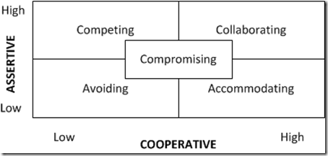](http://sourcesofinsight.com/wp-content/uploads/2011/03/image1.png)

The model organizes 5 conflict management styles based on two dimensions:

Assertiveness and cooperativeness.

## 5 Conflict Management Styles

1. **Accommodating** – This is when you cooperate to a high-degree, and it may be at your own expense, and actually work against your own goals, objectives, and desired outcomes.  This approach is effective when the other party is the expert or has a better solution.  It can also be effective for preserving future relations with the other party.
2. **Avoiding** – This is when you simply avoid the issue.  You aren’t helping the other party reach their goals, and you aren’t assertively pursuing your own.  This works when the issue is trivial or when you have no chance of winning.   It can also be effective when the issue would be very costly.  It’s also very effective when the atmosphere is emotionally charged and you need to create some space. Sometimes issues will resolve themselves, but “hope is not a strategy”, and, in general, avoiding is not a good long term strategy.
3. **Collaborating** – This is where you partner or pair up with the other party to achieve both of your goals.  This is how you break free of the “win-lose” paradigm and seek the “win-win.”  This can be effective for complex scenarios where you need to find a novel solution.  This can also mean re-framing the challenge to create a bigger space and room for everybody’s ideas.  The downside is that it requires a high-degree of trust and reaching a consensus can require a lot of time and effort to get everybody on board and to synthesize all the ideas.
4. **Competing** – This is the “win-lose” approach.  You act in a very assertive way to achieve your goals, without seeking to cooperate with the other party, and it may be at the expense of the other party.    This approach may be appropriate for emergencies when time is of the essence, or when you need quick, decisive action, and people are aware of and support the approach.
5. **Compromising** – This is the “lose-lose” scenario where neither party really achieves what they want.  This requires a moderate level of assertiveness and cooperation.  It may be appropriate for scenarios where you need a temporary solution, or where both sides have equally important goals.   The trap is to fall into compromising as an easy way out, when collaborating would produce a better solution.

By knowing your own default patterns you improve your self-awareness.  Once you are aware of your own patterns, you can pay attention to whether they are working for you and you can **explore alternatives**.

By using a scenario-based approach, you can **choose more effective conflict management styles** and test their effectiveness for you and your situations.

**Negotiation**

Negotiation is a method by which people settle differences. It is a process by which compromise or agreement is reached while avoiding argument and dispute.

In any disagreement, individuals understandably aim to achieve the best possible outcome for their position (or perhaps an organisation they represent). However, the principles of fairness, seeking mutual benefit and maintaining a relationship are the keys to a successful outcome.

**Stages of Negotiation**

In order to achieve a desirable outcome, it may be useful to follow a structured approach to negotiation. For example, in a work situation a meeting may need to be arranged in which all parties involved can come together.

The process of negotiation includes the following stages:

1. Preparation

Before any negotiation takes place, a decision needs to be taken as to when and where a meeting will take place to discuss the problem and who will attend. Setting a limited time-scale can also be helpful to prevent the disagreement continuing.

This stage involves ensuring all the pertinent facts of the Negotiation

Negotiation is a method by which people settle differences. It is a process by which compromise or agreement is reached while avoiding argument and dispute.

In any disagreement, individuals understandably aim to achieve the best possible outcome for their position (or perhaps an organisation they represent). However, the principles of fairness, seeking mutual benefit and maintaining a relationship are the keys to a successful outcome.

Stages of Negotiation

In order to achieve a desirable outcome, it may be useful to follow a structured approach to negotiation. For example, in a work situation a meeting may need to be arranged in which all parties involved can come together.

The process of negotiation includes the following stages:

1. Preparation

Before any negotiation takes place, a decision needs to be taken as to when and where a meeting will take place to discuss the problem and who will attend. Setting a limited time-scale can also be helpful to prevent the disagreement continuing.

This stage involves ensuring all the pertinent facts of the situation are known in order to clarify your own position. In the work example above, this would include knowing the ‘rules’ of your organisation, to whom help is given, when help is not felt appropriate and the grounds for such refusals. Your organisation may well have policies to which you can refer in preparation for the negotiation.

Undertaking preparation before discussing the disagreement will help to avoid further conflict and unnecessarily wasting time during the meeting.

During this stage, individuals or members of each side put forward the case as they see it, i.e their understanding of the situation. Key skills during this stage include questioning, listening and clarifying.

Sometimes it is helpful to take notes during the discussion stage to record all points put forward in case there is need for further clarification. It is extremely important to listen, as when disagreement takes place it is easy to make the mistake of saying too much and listening too little. Each side should have an equal opportunity to present their case.

3. Clarifying Goals

From the discussion, the goals, interests and viewpoints of both sides of the disagreement need to be clarified.

It is helpful to list these factors in order of priority. Through this clarification it is often possible to identify or establish some common ground. Clarification is an essential part of the negotiation process, without it misunderstandings are likely to occur which may cause problems and barriers to reaching a beneficial outcome.

4. Negotiate Towards a Win-Win Outcome

This stage focuses on what is termed a 'win-win' outcome where both sides feel they have gained something positive through the process of negotiation and both sides feel their point of view has been taken into consideration.

A win-win outcome is usually the best result. Although this may not always be possible, through negotiation, it should be the ultimate goal.

Suggestions of alternative strategies and compromises need to be considered at this point. Compromises are often positive alternatives which can often achieve greater benefit for all concerned compared to holding to the original positions.

5. Agreement

Agreement can be achieved once understanding of both sides’ viewpoints and interests have been considered.

It is essential to for everybody involved to keep an open mind in order to achieve an acceptable solution. Any agreement needs to be made perfectly clear so that both sides know what has been decided.

6. Implementing a Course of Action

From the agreement, a course of action has to be implemented to carry through the decision.

Module V

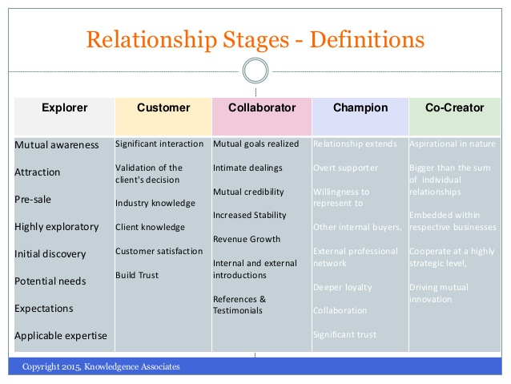

**Types of interpersonal relationship:**

### Friendship

Friendship is an unconditional interpersonal relationship where individuals enter into by their own sweet will and choice.

Friendship is a relationship where there are no formalities and individuals enjoy each other’s presence.

Friendship can be between:

* + Man and a woman
  + Man and man
  + Woman and woman

**Must have in friendship:**

Transparency is the most essential factor for a stable friendship. Do not hide things from your friends. Be honest to them.

Guide them whenever required. Never give them any wrong suggestions or advice.

Feelings like ego, jealousy, hatred, anger do not exist in friendship.

The entire relationship of friendship revolves around trust and give and take. No relationship can be one sided and same with friendship. Try to do as much as you can for your friends.

### Love

An interpersonal relationship characterized by passion, intimacy, trust and respect is called love.

Individuals in a romantic relationship are deeply attached to each other and share a special bond.

**Must have in a Romantic relationship:**

Two partners must trust each other in this relationship.

A sense of respect and mutual admiration is essential.

Partners must reciprocate each other’s feelings for the charm to stay in the relationship for a longer period of time.

### Platonic Relationship

A relationship between two individuals without any feelings or sexual desire for each other is called a platonic relationship.

In such a relationship, a man and a woman are just friends and do not mix love with friendship.

Platonic relationships might end in romantic relationship with both the partners developing mutual love and falling for each other.

### Family Relationship

Individuals related by blood or marriage are said to form a family.

### Professional Relationship (Work Relationship)

Individuals working together for the same organization are said to share a professional relationship.

Individuals sharing a professional relationship are called colleagues. Colleagues may or may not like each other.

Stages in Interpersonal Relationships

Interpersonal relationship refers to a strong association between individuals sharing common interests and goals.

A sense of trust, loyalty and commitment is essential in a relationship.Individuals need to trust and respect their partners to avoid misunderstandings and conflicts in relationship.

Stages in an interpersonal relationship

It takes time for a relationship to grow and pass the test of time.

There are two possibilities in a relationship:

1. **Possibility - 1:** Two people might start a relationship as mere strangers. They get to know each other slowly and become emotionally and mentally attached to their partners gradually. Such relationships often lead to lasting commitments where individuals decide to be with each other until death separates them.
2. **Possibility - 2:** Two people might start off well but soon face problems. Troubles in relationship start when people have different opinions, views and fail to reach to a mutually acceptable solution. In such cases individuals decide to move on from a relationship for a fresh start.

According to famous psychologist George Levinger, every **relationship goes through following five stages**.

1. **First Stage – Acquaintance**

Acquaintance refers to knowing each other. To start relationship individuals need to know each other well.

Two individuals might meet at some place and instantly hit it off. People feel attracted to each other and decide to enter into a relationship.

Common friends, social gatherings, same organizations also help people meet, break the ice, get acquainted with each other and start a relationship.

1. **Second Stage – The Build up Stage**

This is the stage when the relationship actually grows. Individuals are no longer strangers and start trusting each other.

Individuals must be compatible with each other for the relationship to continue for a longer period of time. Individuals with similar interests and backgrounds tend to gel with each other more as compared to individuals from diverse backgrounds and different objectives.

The build up stage in a relationship is often characterized by two individuals coming close, being passionate and feeling for each other.

1. **Third Stage – Continuation Stage**

This is the stage when relationship blossoms into lasting commitments. It is when people after knowing each other well decide to be in each other’s company and tie the knot.

Trust and transparency is essential for the charm to stay in relationship forever.

1. **Fourth Stage – Deterioration**

Not all relationships pass through this stage. Lack of compatibility, trust, love and care often lead to misunderstandings and serious troubles in relationship.

Individuals sometimes find it extremely difficult to adjust with each other and eventually decide to bring their relationship to an end.

Compromise is an integral part of every relationship.Individuals failing to compromise with each other find it difficult to take the relationship to the next level.

1. **Fifth Stage – The Termination Stage**

The fifth and the last stage is the end of a relationship.

Relationship terminates due to any of the following reasons

* + Death of any one partner
  + Divorce
  + Separation

An ideal relationship results in lasting commitments and marriages whereas there are some relationships which do start on a positive note but end abruptly.

Tips to Improve Interpersonal Relations at Workplace

Interpersonal relationship refers to a strong association among employees either working together in the same team or same organization.

Employees must get along well for a positive and healthy ambience at the workplace.

Let us go through some **tips to improve interpersonal relationship at workplace**.

* **Do not treat office as your home**. There is a certain way of behaving at the workplace. It is essential to be professional at work. Never misbehave with any of your colleagues. Legpulling, criticism, backbiting are a strict no no. It is better to avoid someone you don’t like rather than fighting or arguing with him/her. Your office colleagues can be your friends as well but one must know where to draw the line. Too much of friendship is harmful and spoils relationship among employees.
* **An individual should not interfere in his colleague’s work**. Superiors must formulate specific KRAs for all the employees and make sure job responsibilities do not overlap. Overlapping of job responsibility leads to employees interfering in each other’s tasks and eventually fighting over small issues. One should be concerned only with his work rather than trying to find out what the other employee is up to.
* **Give space to your fellow workers**. Giving space infact is essential in all relationships. Overhearing anyone else’s personal conversation is strictly unprofessional. An employee must not open envelopes, couriers or letters not meant for him. Such practices lead to severe displeasure among employees and eventually spoil relationships.
* **Do not spread baseless rumours at workplace**. Even if you know something about someone, learn to keep things to yourself. Discuss it with the individual concerned in private rather than publicizing the whole thing. Organization has nothing to do with anyone’s private matters.
* **Pass on correct information to others**. If your superior has asked you to share some information with any of your colleagues, make sure it is shared in its desired form. Data tampering and playing with information spoil relationships among colleagues and lead to confusions at the workplace.
* **Do not share all your secrets with your co workers**. You never know when they might misuse them. Even if you do, make sure you are doing it with someone you trust blindly.
* **Leave your ego behind**. Do not bring your personal tensions to work. Think before you speak. Making fun of colleagues is something which is not at all expected out of a professional.
* **A team leader should not scold any of his team members in front of others**. It might insult him/her. Call the individual concerned either to your cabin or conference room. Avoid comparisons among team members. The employees must be strictly judged according to their work and nothing else. Employees doing well should be suitably rewarded.
* **Stay away from nasty**[**politics at workplace**](https://www.managementstudyguide.com/workplace-politics.htm). Do not try to harm anyone. It is absolutely okay to appreciate someone who has done something exceptionally well. Avoid being jealous. It will harm you in the long run. There should be healthy competition among the employees for a healthy environment at the workplace.

**Module VI:**

There are three stages a person goes through while suffering from stress.

**Alarm Stage:** Look at a student's face just before he is going to give an exam. Isn't the fear and tension clearly evident? When something has just started stressing you and you feel a fight or flight kind of attitude, then you are in the alarm stage of stress. It is the start up stage which defines the first reaction to the stressors.

**Resistance Stage:** When a child is sitting in the examination hall and writing his exam, he is bothered about completing it in time. He is making full efforts to cope with the situation and his whole body is engaged in fighting against the condition. This is the resistance stage. In this stage, the body keeps making continuous efforts to cope with stress and therefore feels run down and exhausted. The person starts feeling irritated, over reacts to minor situations and gets mentally and physically weak. Psychological, physical and behavioral changes are also clearly visible.

**Exhaustion Stage:** If a student is preparing for his exam and despite of every possible effort, he is not able to relate to his studies, he is bound to get stressed. The stress could reach a height where he/she may feel completely exhausted and helpless to the extent of committing suicide. This is the exhaustion stage. This stage is further divided into two phases:

Initial phase: The stress persists and due to lack of appropriate measures the person is not able to concentrate and work efficiently.

Burnout: The person is completely exhausted and drained of all energy reserves. There is a complete physical, psychological and emotional breakdown. This requires immediate attention.

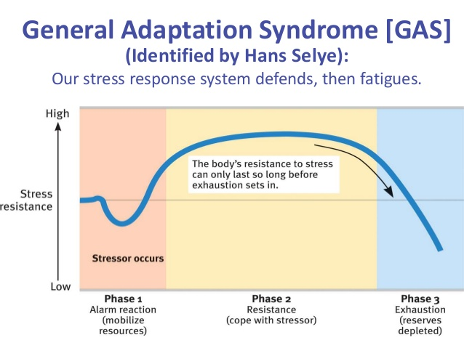

**Causes and symptoms of stress**

Causes of stress vary from person to person. Some common causes of stress can be a death of a family member, illness, taking care of your family, relationship changes, work, job change, moving and money. Even small things such as long waits or delays or traffic can cause stress.

* Personal
* Some of the leading personal causes of stress are:
* * Finances; who name finances as the leading cause of stress cite major purchases they have to make, such as a home or car. Others are stressed by a loss of income, or mounting credit card debt. For some, financial stress will eventuate in bankruptcy. While college students stress over paying for an education, Baby Boomers and older senior ci tizens find that retirement income can be a major cause of stress.
* * Personal Health and Safety; For some, the stress is linked to obesity, and a desire to lose weight. For others, the stress is a personal bas habit that affects health and must be changed. For example, smoking, abuse of alcohol or other drugs. Illness or injury, whether less or more serious, can be a leading cause of stress for many people. Personal safety is also a leading cause of stress. Women, more than men, tend to stress about their own and others’ safety. Adults tend to stress more than young people, who may act invincible.

* Personal Relationships; Whether it is a friendship, dating, separation, marriage, divorce, or re-marriage, a relationship can be a leading cause of stress for many. We all want love, and that is potentially available in relationships, but getting from A to B can be very stressful. Some resort to online relationships that are easier to handle. Others withdraw and become recluses. Either way, the demands on time, finances, and emotions can cause ongoing stress.

* Death; Probably the most wrenching cause of stress is the death of a loved one or close friend. Even the death of a pet can be stressful.

Organizational

There are 6 risk factors these are:

■ Demands – such as workload, work patterns and the work environment.

■ Control – such as how much say the person has in the way they do their work.

■ Support – such as the encouragement, sponsorship and resources provided by the organisation, line management and colleagues.

■ Relationships – such as promoting positive working to avoid conflict and dealing with unacceptable behaviour.

■ Role – such as whether people understand their role within the organisation and whether the organisation ensures that they do not have conflicting roles.

■ Change – such as how organisational change (large or small) is managed and communicated in the organisation. (HSE 2005)

All of the above risk factors appear often highly recognizable within the companies.

Employee Risk Factors: Stress can pose a significant risk to the individual in both mental and physical health. Mental health risks include depression, anxiety and post traumatic stress disorders. Physical risk factors include damage to immune and cardiovascular systems. Stress can also increase the risk of other more serious ill health issues such as Heart Disease. As identified within the Management Standards high demands within the job such as the working environment and workload are known to be some of the highest risk factors which have proven to result in stress within any individual.

Employer Risk Factors: Risk factors for employers can be divided into four main categories these being: Cost, Negative Public Relations, Legal Obligation/Criminal Prosecution and Civil Action by employees. The risk factors above are often found within the organisations we have carried out Stress Surveys for. Although employers do have demanding roles we often find that the most noted form of stress within organizations is found because they have the inability to make significant changes as ideas are often unsupported and change within the organisation is met with great resilience.

Environmental

Physical

* Noise

* Hot environment

* Cold environment

* Poor lighting/too much lighting

* Organizational Risk factors

* Faulty equipment

* Poorly designed and/or maintained equipment

* Dangerous equipment

* Heavy weights

**Effect of stress on performance**

Look at the curve. Our ability to perform increases up to a certain level of stress arousal. This is the healthy tension or eustress. But if this stress continues uncontrolled and a fatigue point is reached, any further stress arousal will take the performance level down, ultimately leading to exhaustion, ill-health and, finally breakdown.

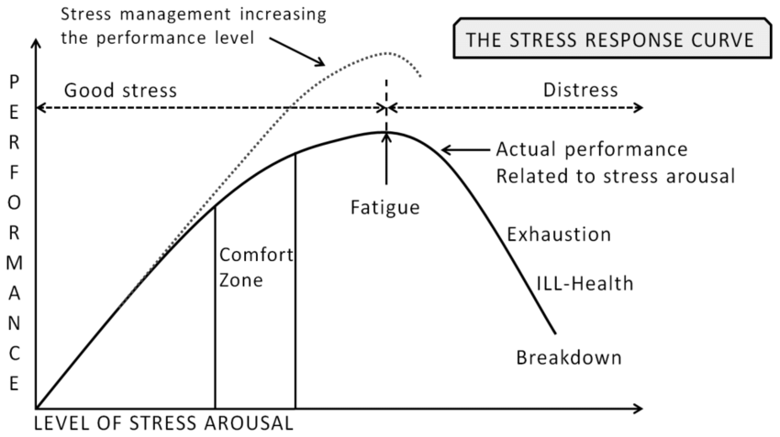

**Strategies for stress management**

Importance of stress management

It may seem that there’s nothing you can do about your stress level. The bills aren’t going to stop coming, there will never be more hours in the day for all your errands, and your career or family responsibilities will always be demanding. But you have a lot more control than you might think. In fact, the simple realization that you’re in control of your life is the foundation of stress management.

Managing stress is all about taking charge: taking charge of your thoughts, your emotions, your schedule, your environment, and the way you deal with problems. The ultimate goal is a balanced life, with time for work, relationships, relaxation, and fun – plus the resilience to hold up under pressure and meet challenges head on.

Unhealthy ways of coping with stress

These coping strategies may temporarily reduce stress, but they cause more damage in the long run:

* Smoking * Drinking too much * Overeating or undereating * Zoning out for hours in front of the TV or computer * Withdrawing from friends, family, and activities * Using pills or drugs to relax * Sleeping too much * Procrastinating * Filling up every minute of the day to avoid facing problems * Taking out your stress on others (lashing out, angry outbursts, physical violence)

**Tips for Coping with Stress**

Watch for signs of stress. When they occur, try to avoid the cause or change how you react. Other helpful tips:

• Do something that relaxes you such as: deep and slow breathing, stretching exercises, yoga, a massage, meditation, listening to music, reading, a hot bath or shower.

• Get a hobby or do something you enjoy.

• Learn to accept things that you cannot change.

• Think positive.

• Set limits. Learn to say no. Take one thing at a time.

• Get 8 hours of sleep each night.

• Eat a healthy diet that includes fruits, vegetables, protein and whole grains.

Limit caffeine and sugar. • Exercise regularly. Exercise will help relax tense muscles, improve your mood and help you sleep better.

• Talk to your family and friends about your problems. • Do not deal with stress in unhealthy ways such as eating too much, not eatingenough, using tobacco products, drinking alcohol or using drugs. • Get help from a professional if you need it. A counselor can help you cope with stress and deal with problems. Your doctor may prescribe medicines to help with sad feelings, nervousness or trouble sleeping.

**Impression Management**

Impression management refers to the activity of controlling information to steer others’ opinions in the service of personal or social goals. Although people can manage impressions of almost anything (e.g., a clothing brand, a political position), people most commonly manage the impressions others form of themselves, a subtype of impression management that is often termed as self-presentation.

Impression Management History and Modern Usage

Impression management is not risk-free, however. Becoming excessively concerned over others’ opinions can cause anxiety, thereby increasing health problems. And engaging in highly deceptive forms of impression management runs the risk that people will see through the act (although “getting caught” seems to be the exception rather than the rule). Conversely, impression management may sometimes be too effective; for example, if you try to act like a rebel in one situation, your impression management may carry over such that you start to see yourself as relatively more rebellious and behave in a rebellious manner in subsequent situations. Of course, to the extent that people generally try to put their best foot forward, such carryover effects of immpression management may have positive consequences.

Impression management can also be used prosocially to benefit friends. People commonly describe their friends in ways that help to support their friends’ desired images. Thus, impression management can be undertaken in the service of self-serving or more other-oriented goals and represents a central component of everyday social life.

What is Impression Management?

When a person is trying to mould his natural behavior just to manage a particular situation or to look good in front of others then he is following the art of Impression Management. It makes us feel good if we claim to be an expert at something and people around you accept the same. This helps in increasing their self-confidence and raising their self-esteem. After making a good impression it becomes easier to influence others to dance on your own tunes. People, in day to day life, widely use this technique of Impression Management to effect a change in personality.

A real life example may be that a person who has a habit of wearing shabby clothes grooms himself very nicely just before going for a party, for an interview or for a date. This acts as a feel good factor for many individuals and thus increases their confidence. Somebody has rightly said, “First impression is the last impression”. This worldly accepted famous quote in itself tells about the need and importance of Impression Management. And a more assertive way to quote this is by adding, “And you never get a second chance to make the first impression”.

How to use Impression Management effectively? There are several ways by which people can use the concept of Impression Management to make them look superior to what they actually are. Some of these are:

• People tend to talk about their personal characteristics portraying them in a manner so as to make themselves look superior amongst all.

• People often conform from a desire to achieve a sense of security within a group.

• People tend to give excuses or try to justify their acts so as to make them acceptable to everyone.

• These days people try to portray their deceptive nature of being courteous just to show how down to earth they are and how readily they accept their mistakes.

• If somebody has achieved something high and of great importance then people tend to take credit of that worthy act by telling everybody how they played a vital role by offering a helping hand to accomplish the task.

• Cajoling is the one way of making yourself likeable by everybody as it’s a typical human behavior of people who like being flattered. This is the best way to make things work.

• Returning favors of the good behavior that is showed to you can create miracles for people who do the same. This is “Good Tit for Tat’ method.

Why do people adopt the technique of Impression Management? There are basically two main reasons that drive people to adopt the art Impression Management which are:

1. Effectiveness: Many people feel that by managing their impression they can get by on charm on any person and make them work according to their wishes i.e. people show the other side of their personality to match people requirements from place to place. E.g. A boy coming out of a Mercedes Benz which is borrowed from one of his friend and branded clothes to pick up his girlfriend just to show how rich he is trying to make the girl flattered.

2. Conflict avoidance: The best way to avoid conflict is to act sweet specially to those who like people with soft voices. People who follow the art of Impression Management never try to win an argument. They believe in, “Never win an argument, you often lose a friend”. E.g. Reconciling with the other person in spite of knowing that he was wrong and himself believes in, “A reconciled friend is double enemy”.

Managing impression at a job interview People take care of the following things for managing impression at the time of appearing for an interview:

1. Dressing Style: No matter how old or dirty shirt they usually wear but at the D-day, they will wear the best of their collections or many a times even a new shirt.

2. Punctuality: Some people have a habit of procrastinating work for the end moment which sometimes leads to overshoot the deadline but they will make sure that they reach the interview center well before time just to show that they are punctual.

3. Humility: Some people are very arrogant by nature but during those 15 minutes of the interview, to crack the interview, they try to act as humble as possible just because they know how much important this trait is.

4. Body Language: People take personality development classes before appearing for an interview. There they learn that no matter how much stressed the interview is, always try to carry a smile and try not to cross legs or to press hands.

On the contrary, these days many interviews are supplemented with psychometric tests of personality to know that, is the candidate faking the interview or trying to fit-in for the job? As this it is likely to lead to problems down the line as the true self emerges.

I would like to explain my point of view by taking Satyam as an example. As you all are aware, they managed the impression of being a financially sound company which helped them to maintain their stock price to a high level. But internally the company was in fraudulent activities which led their debacle resulting in degrading its own reputation. Thus, Using Impression Management any organization can achieve success but it is always short lived. No matter how much you try to deceive, someday or the other the truth comes out.

At the last I want to quote that, “By Impression Management, you can get on by on charm on someone for just the first 15 minutes, after that you better know something”

**Importance of Time Management:**

1. Time cannot be recall

2. Every work required time

3. Everyone has same time

Characteristics of time:

1. Neutral

2. Time cannot be save for the future prospectus

3. It is equivalent to money or much important than the money

Factors of time wasting:

1. Recall old things

2. Excessive thinking about the future

3. No work Strategy

4. Laziness

5. Interruptions

Benefits of Time Management:

1. Organized life

2. Reduce stress

3. working efficiency enhance

4. More time

5. Internal Motivation

6. No excuses

7. Less anxiety

8. Healthy family relationship

9. More energy

10. Healthy life

